Assignment 3

Yixin Yin

1.

Process to crack windows 7 password by Kali Linux

Environment:

Main System: Windows 10 Professional

Virtual Machine: VMware Workstation 12 Player

Virtual Operating System: Windows 7 Professional and Kali Linux 2.0 amd64





First I use Windows 7 Operating System iso on my virtual machine.

And I also create 5 accounts which have different length of password

The username and password are following:

Administrator : yyx

yyx1: yyx123

yyx2:nevermore6

yyx3:yyx199107191

yyx4:computernetworkdefense

Here is the screenshots:

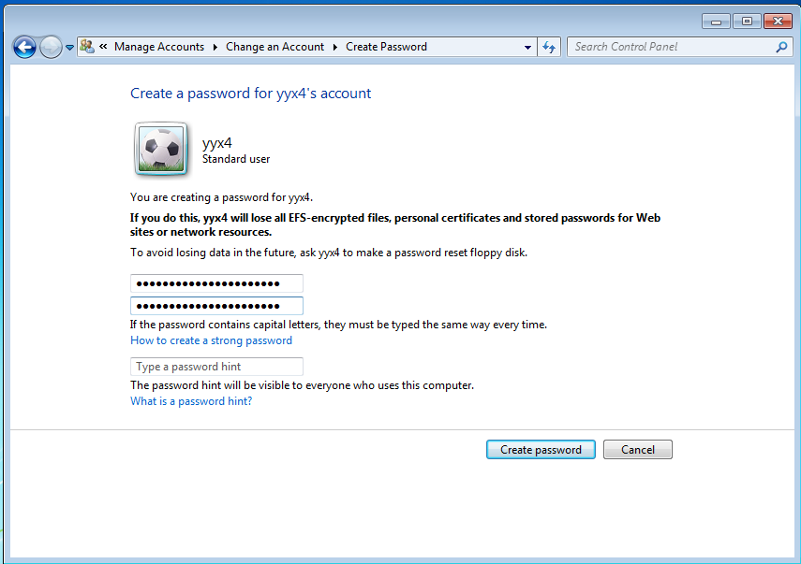

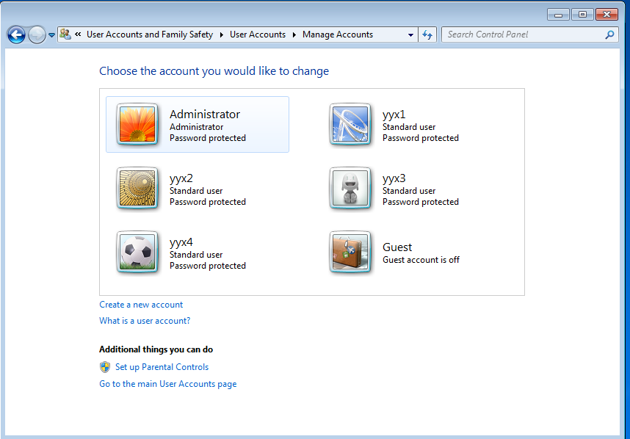  
This is the 5 accounts (Guest account is off)

Then I change the iso to Kali Linux

In the configuration menu, change the iso file to Kali-Linux-2.0

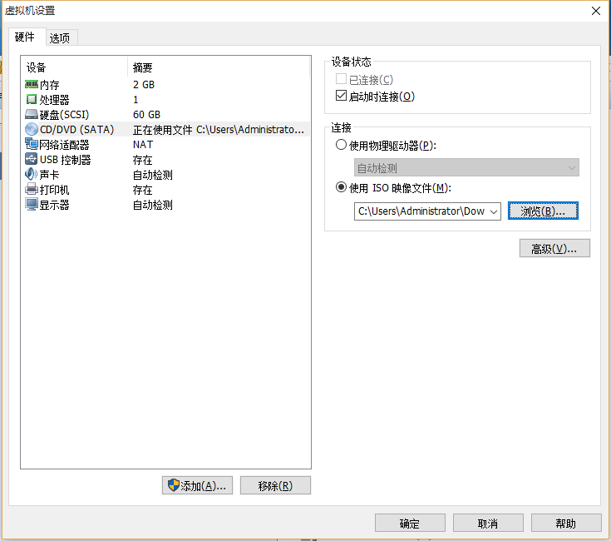

Then we need to click esc in the at the vmware login image

Then the virtual machine should be like this

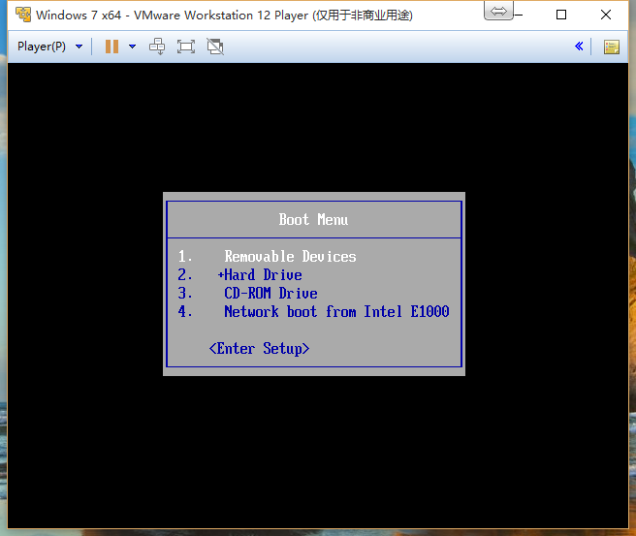

We then choose 3 CD-ROM Drive boot option

Then the vm should be like

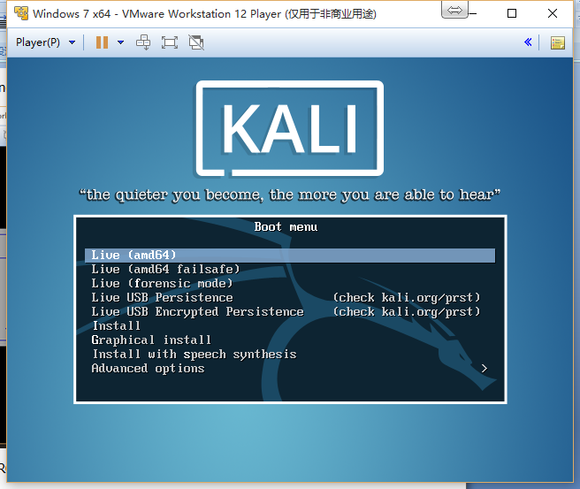

We choose the first one, Live(amd64)

At that point we have already login into Kali Linux and Kali and Windows are on the same disk

Then we open the command line and input the commands step by step.

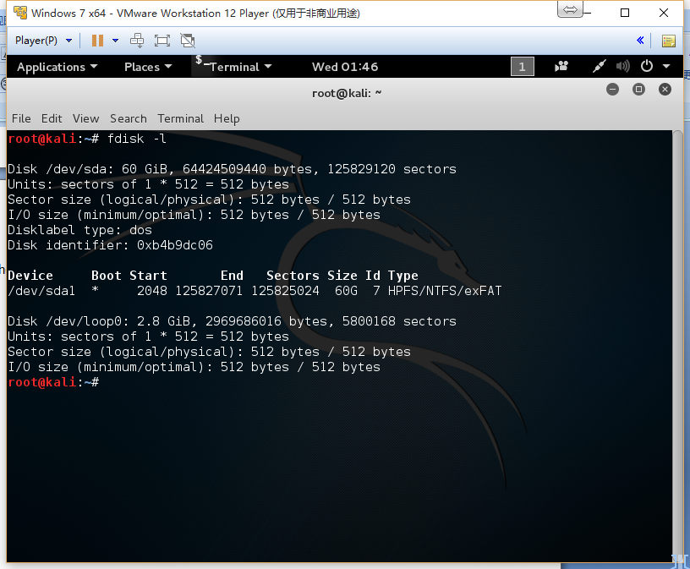

(1)fdisk –l

by this we could find the disk information

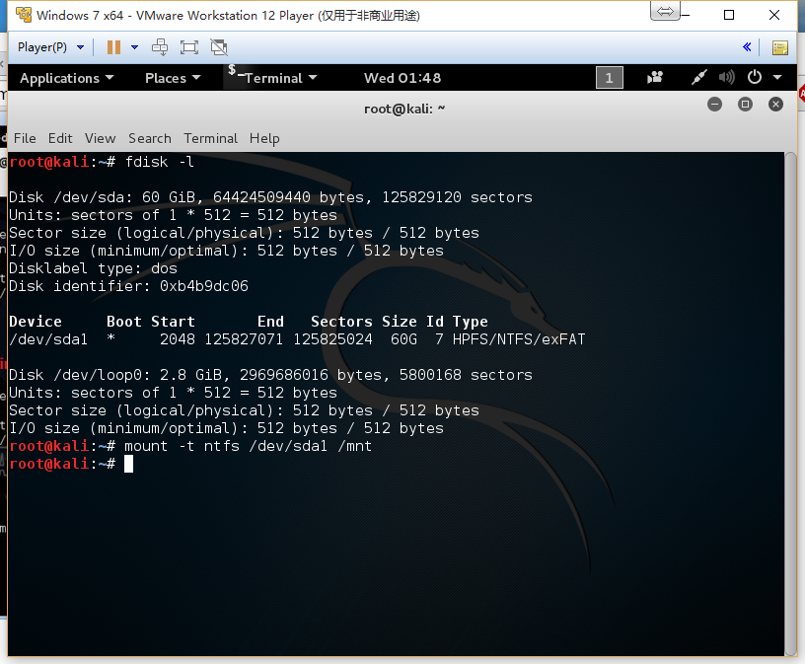

(2)sudo mount –o ro /dev/sda1 /mnt

By this we mount the windows system disk into /mnt directory

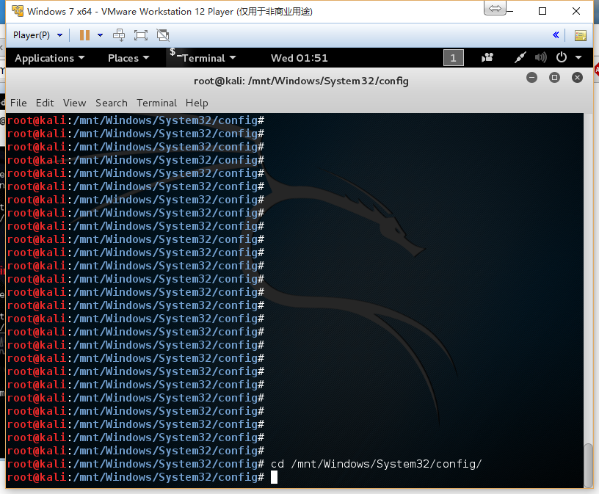

(3)cd /mnt/Windows/System32/config/

By this we go into the config directory

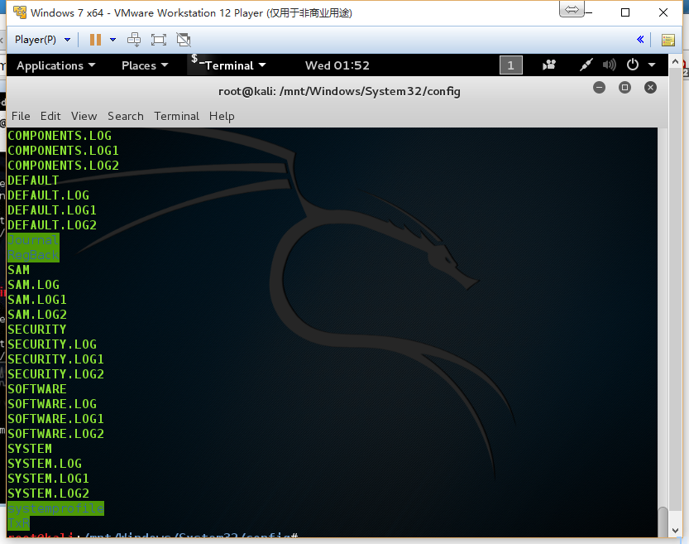

We could find the SAM file is here

(4)samdump2 SYSTEM SAM > /root/myhash.txt

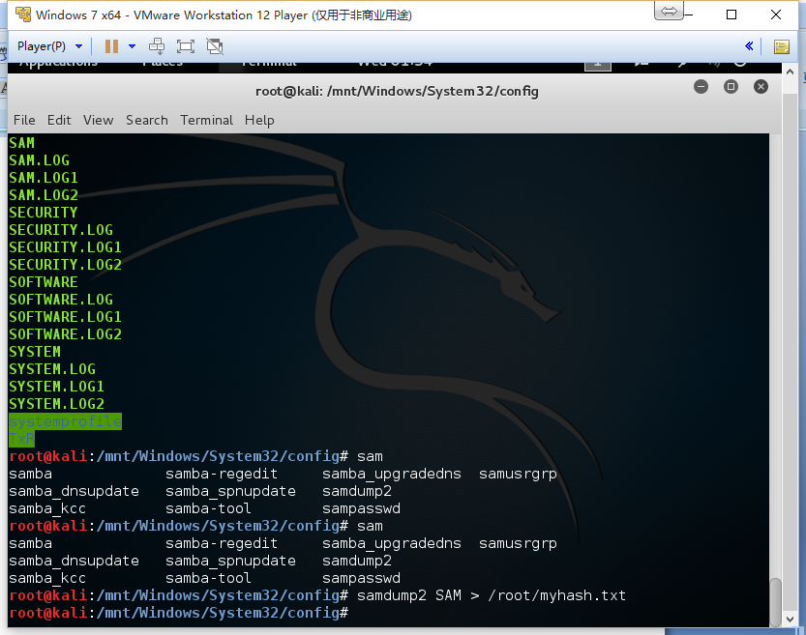

(5)cd /root

cat myhash.txt

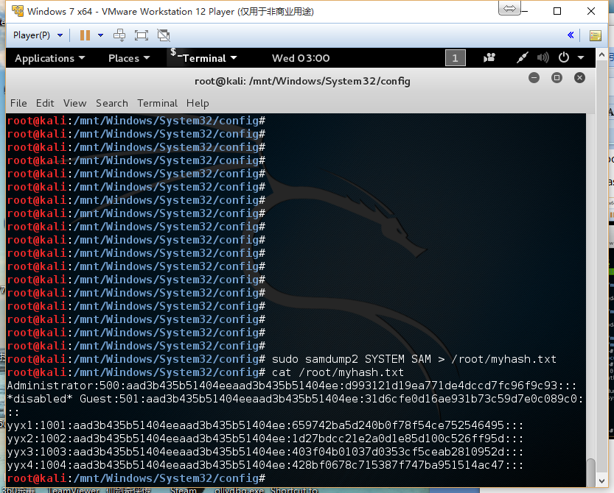

So we get the hash of the passwords

Then we try to use John to crack the password

(6)john /root/myhash.txt –format=NT

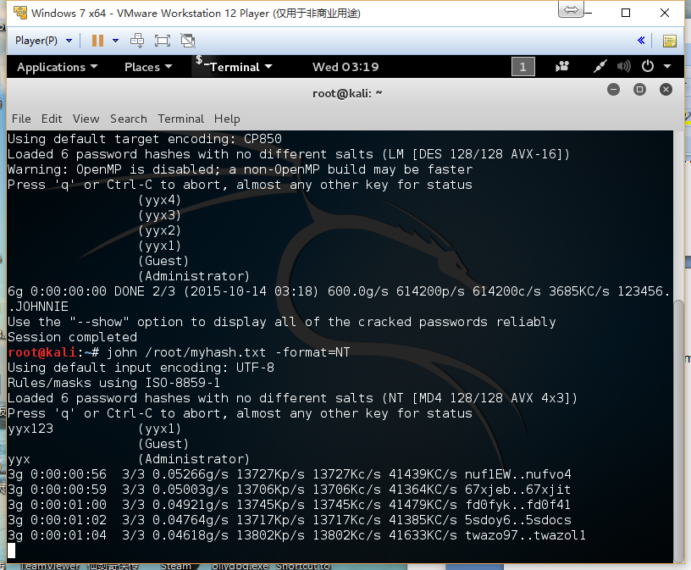

So the short passwords are cracked very fast, but the longer password needs some time.

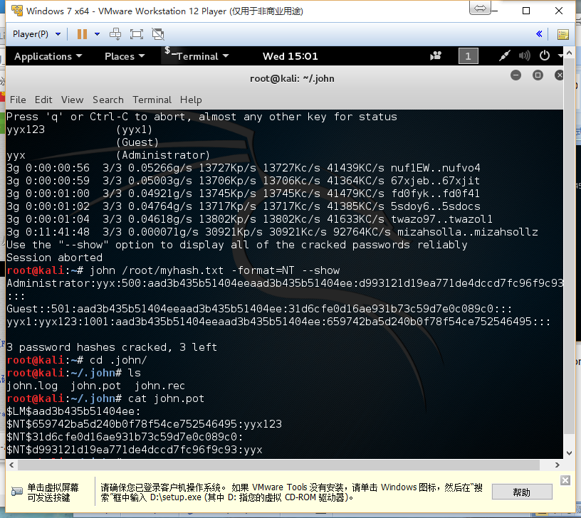

We can see that only two of them are cracked successfully. (it shows 3 password hashes cracked because one of them is guest account, it doesn’t have a password)

The hashes for Administrator, yyx1, yyx2, yyx3, yyx4 are:

D993121D19EA771DE4DCCD7FC96F9C93

659742BA5D240B0F78F54CE752546495

1D27BDCC21E2A0D1E85D100C526FF95D

403F04B01037D0353CF5CEAB2810952D

428BF0678C715387F747BA951514AC47

I then use the online cracked database to crack but only three of them are cracked

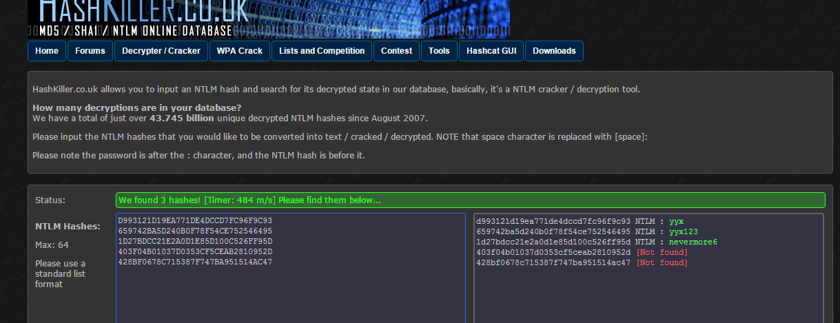

It is because they use pre-compute way to map the passwords and the hashes. But unluckily my passwords are not in their dictionary so they can not find it. <http://www.hashkiller.co.uk/ntlm-decrypter.aspx>

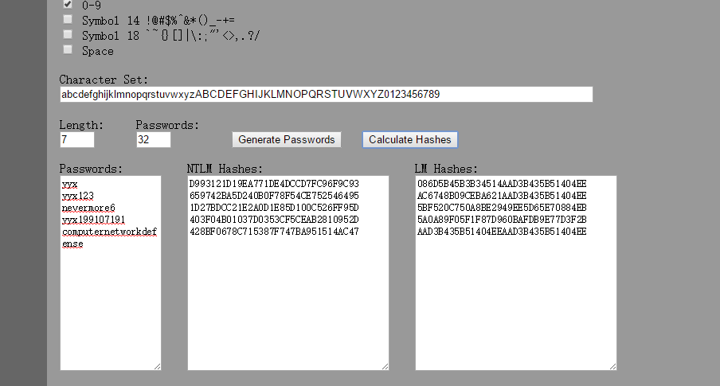

I also find a hash calculator online, so I input my passwords in it and the NTML hashes are the same with I found in the SAM file. <http://www.tobtu.com/lmntlm.php>

Finally I decide to use Amazon Elastic Cloud to computer the hashes.

First I need to copy the myhash.txt to my computer and put it on the cloud server.

(7) cp myhash.txt Desktop/

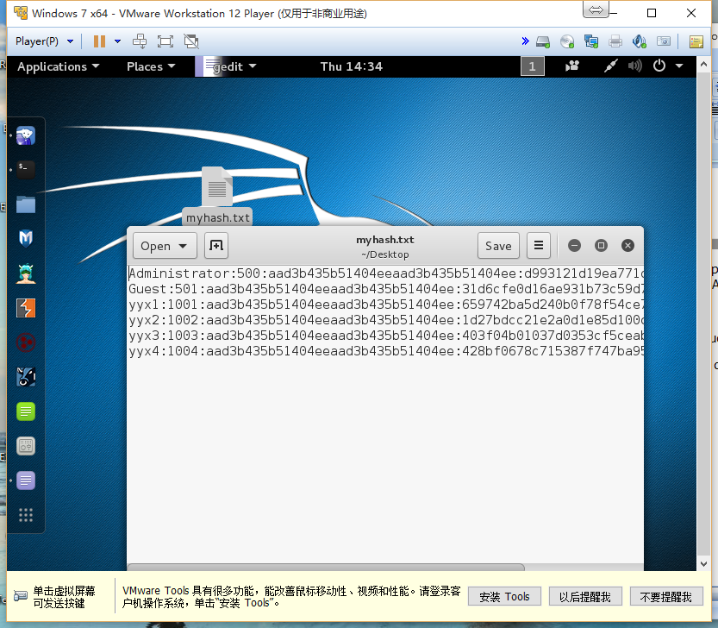

(8) then I use these command to upload myhash.txt to the server

sudo scp -i yyx1.pem -P 22 myhash.txt admin@54.174.222.33:

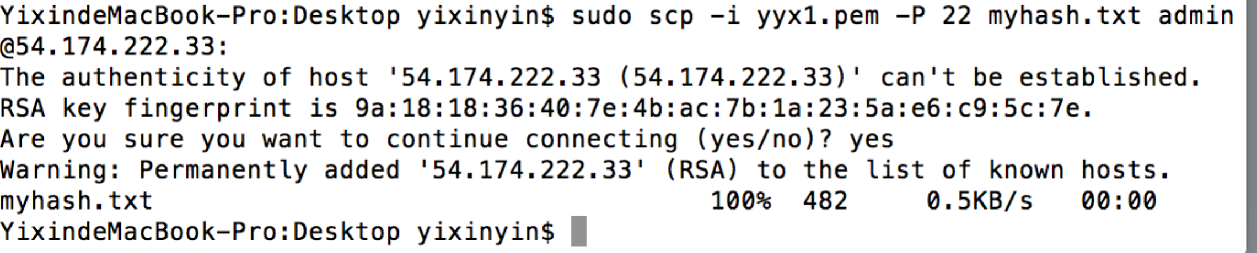

Finally the myhash.txt is on my server

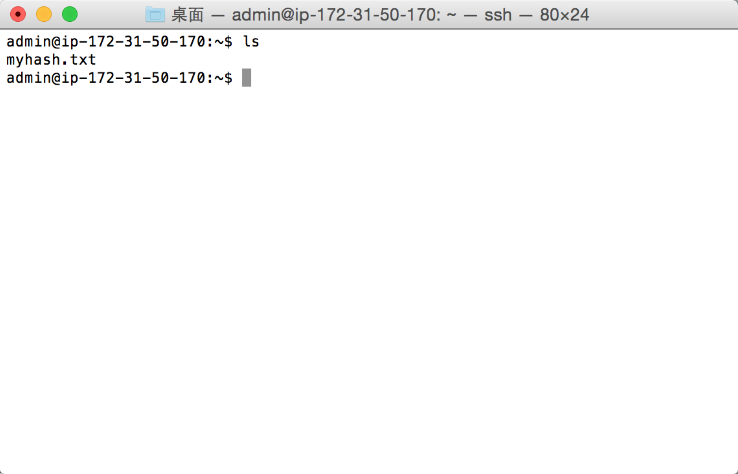

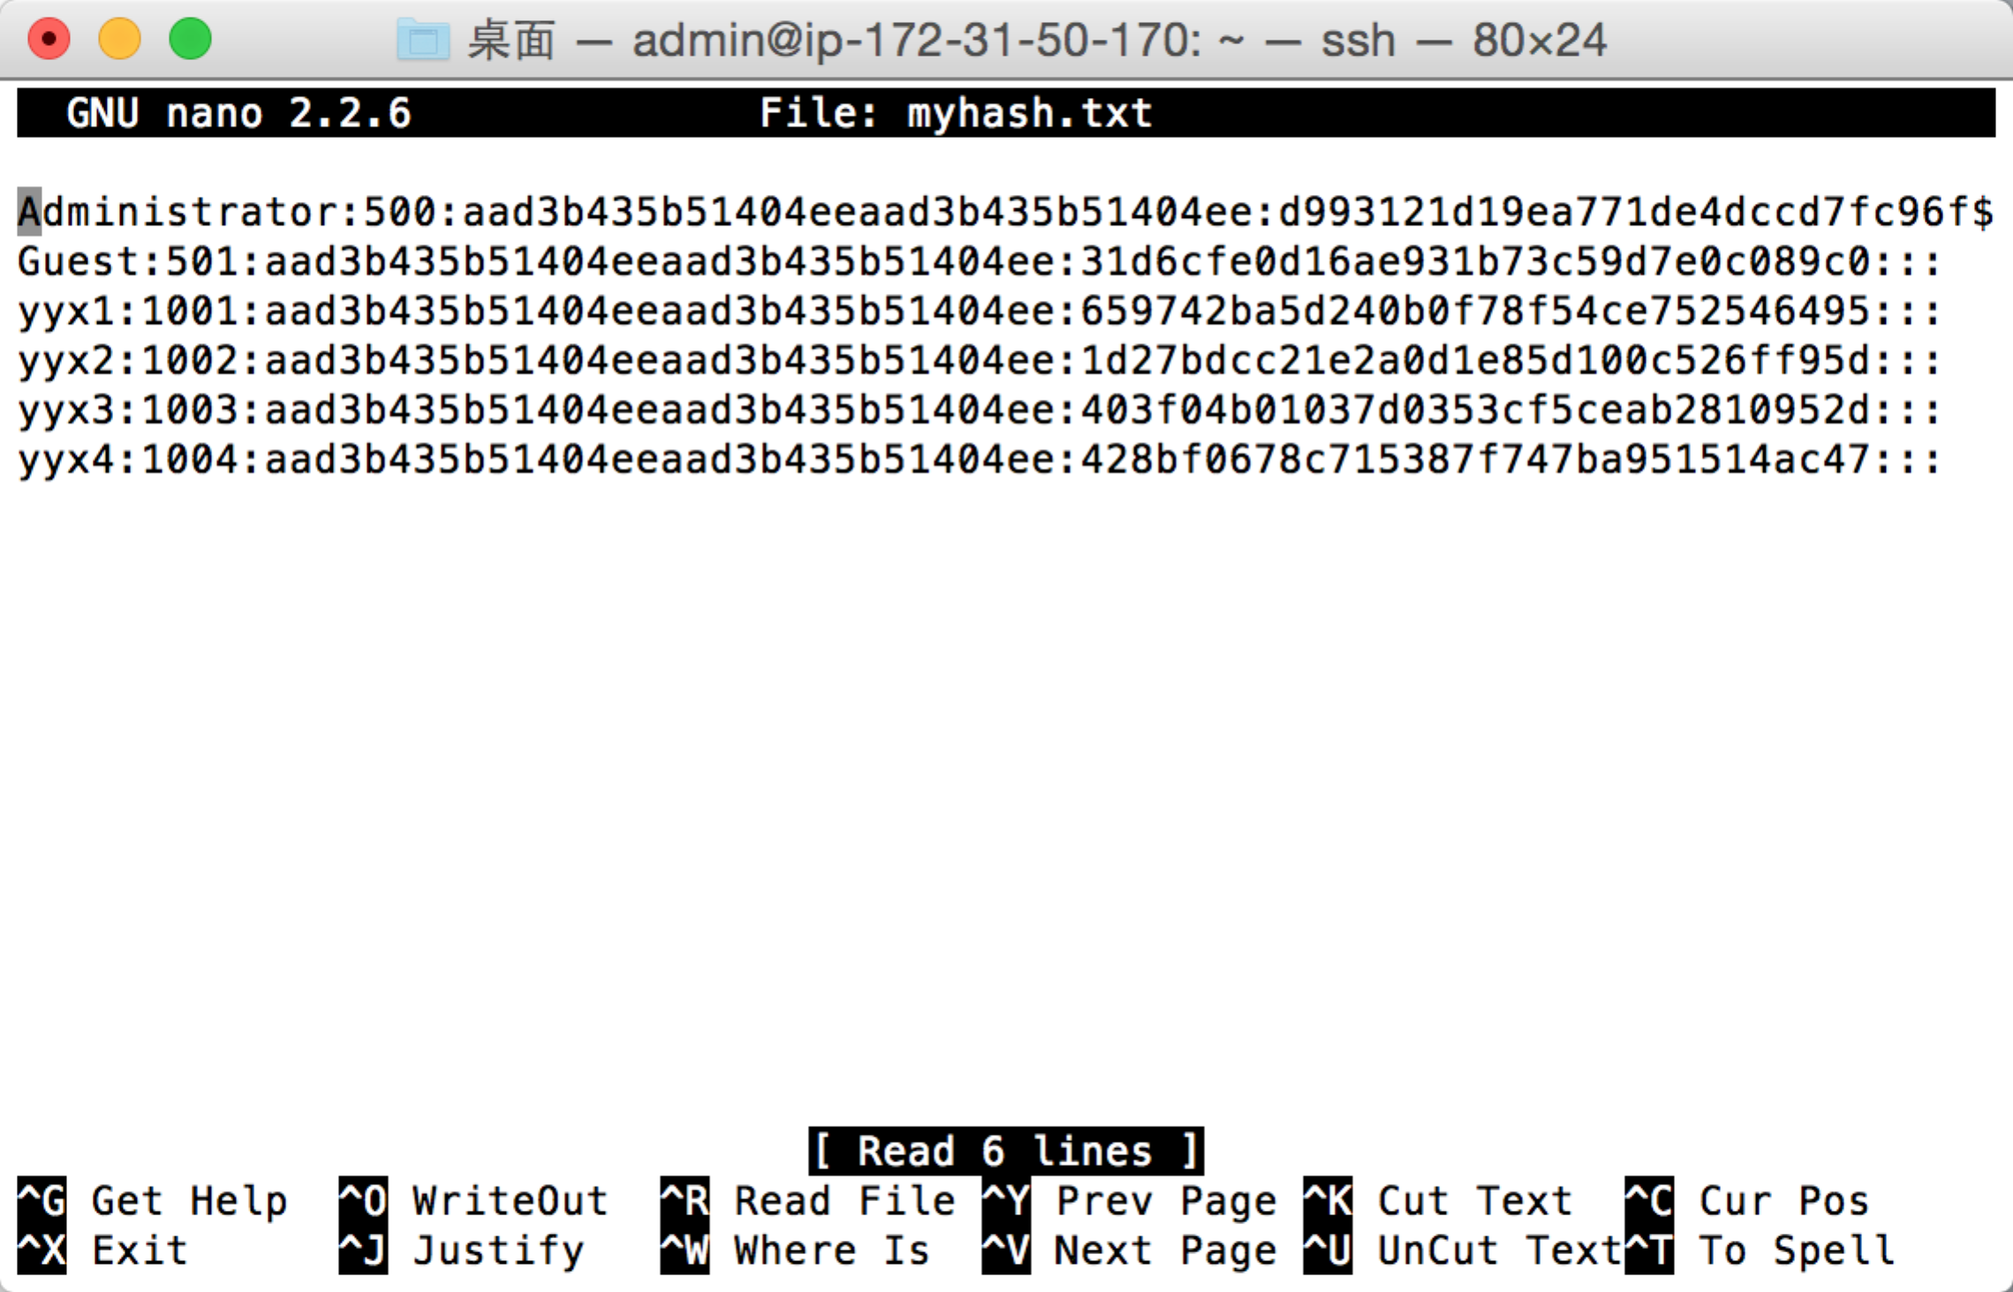

(9)The last step is to use john to crack the hash and wait for the cracked. Because my passwords are a little bit long, so I am not sure whether it will success.

Now it is Oct 15th, I will try to run it till next Wednesday(Oct 21st).

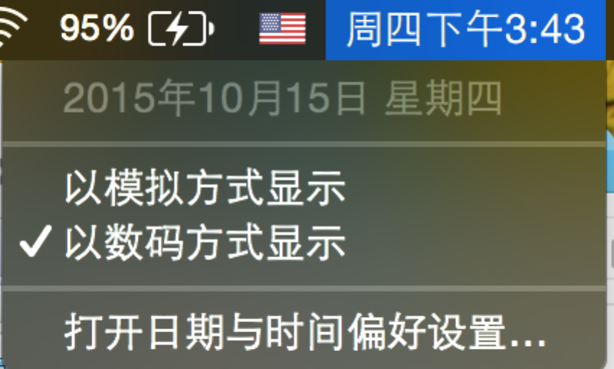

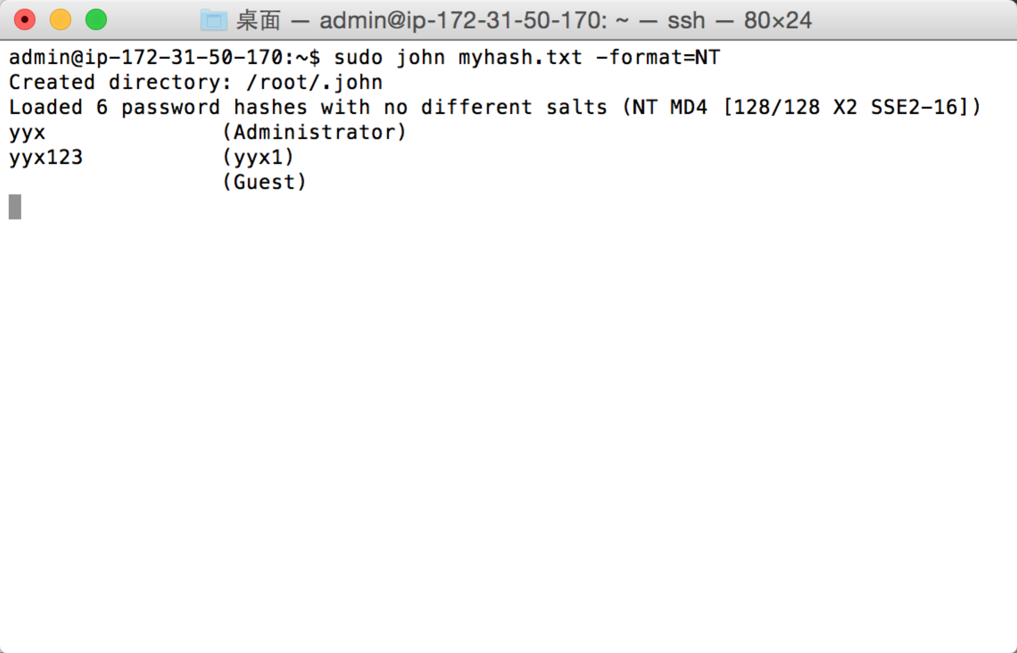

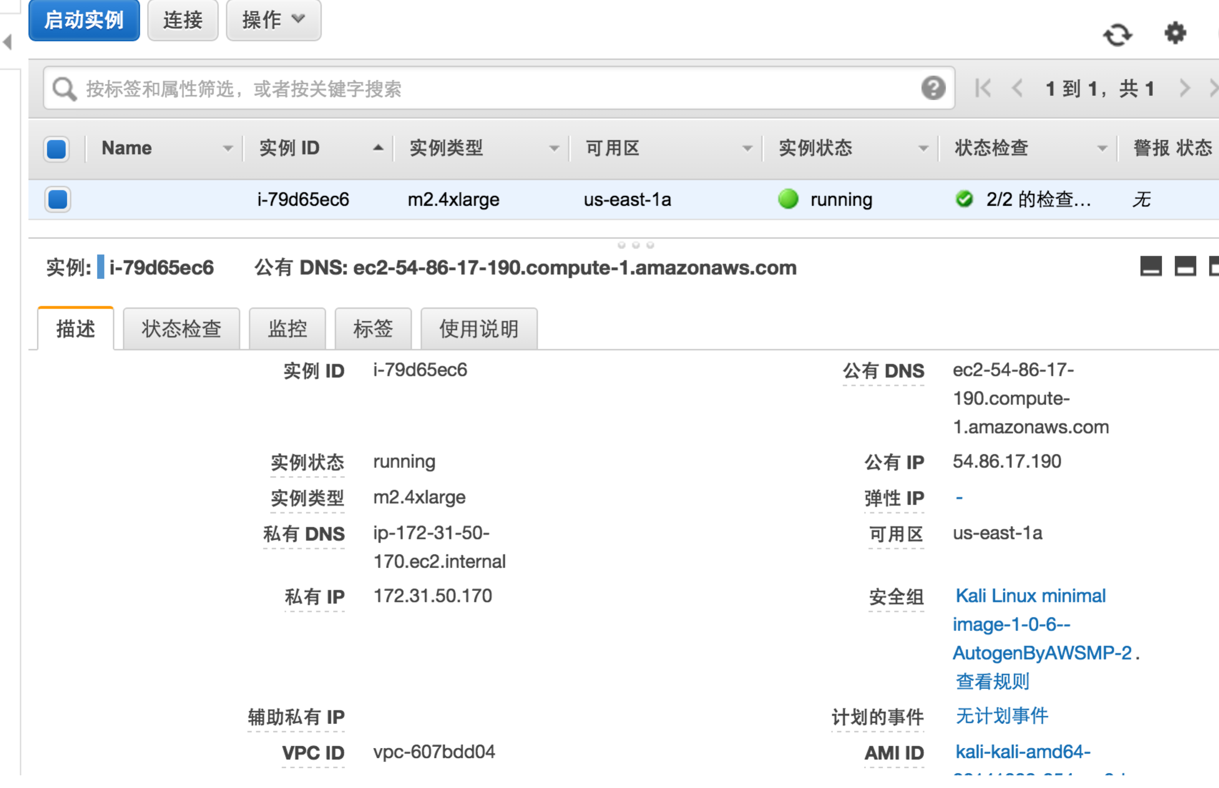

I use the m2.4*large instance to run john the ripper. I run it several days, but because my password is so long, so it just can not be decrypted.

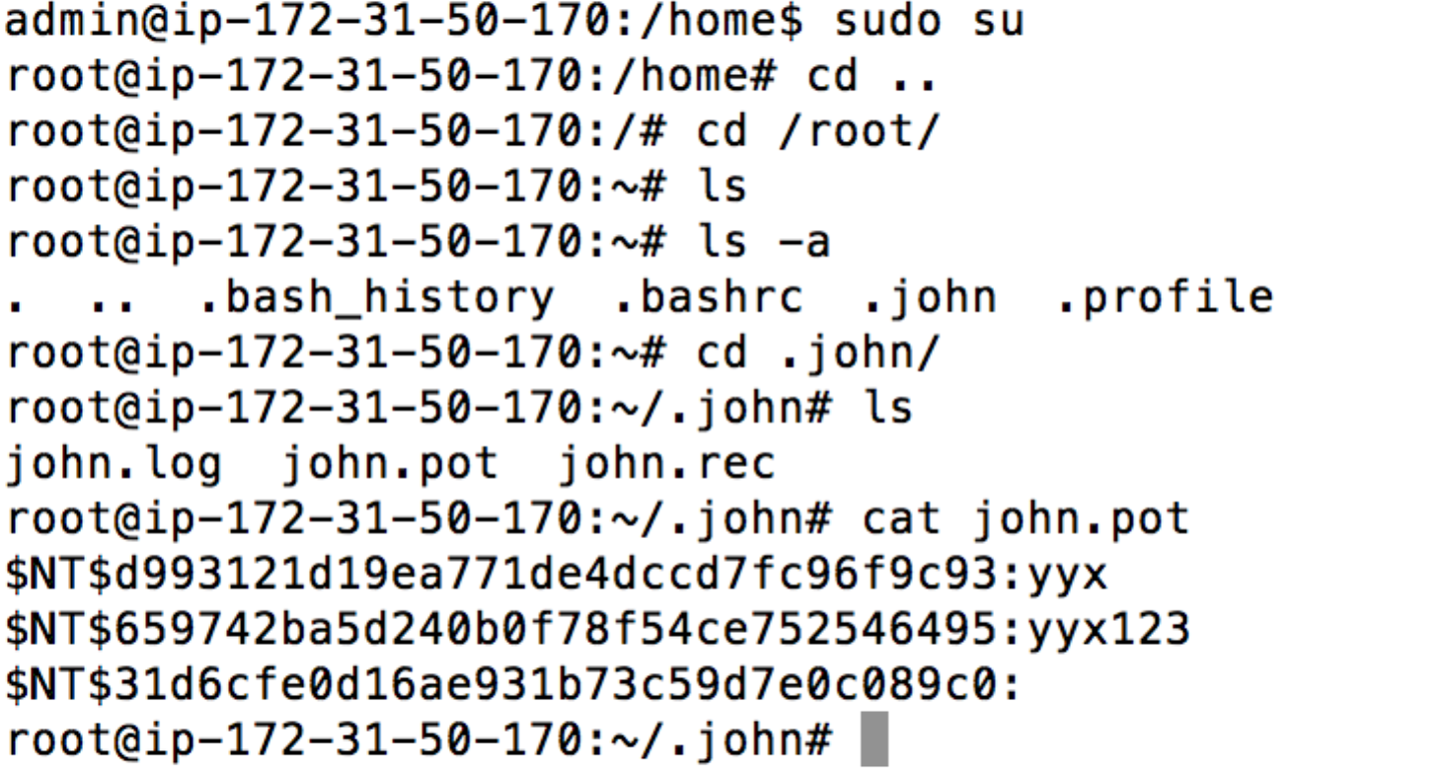

Here is the running log.

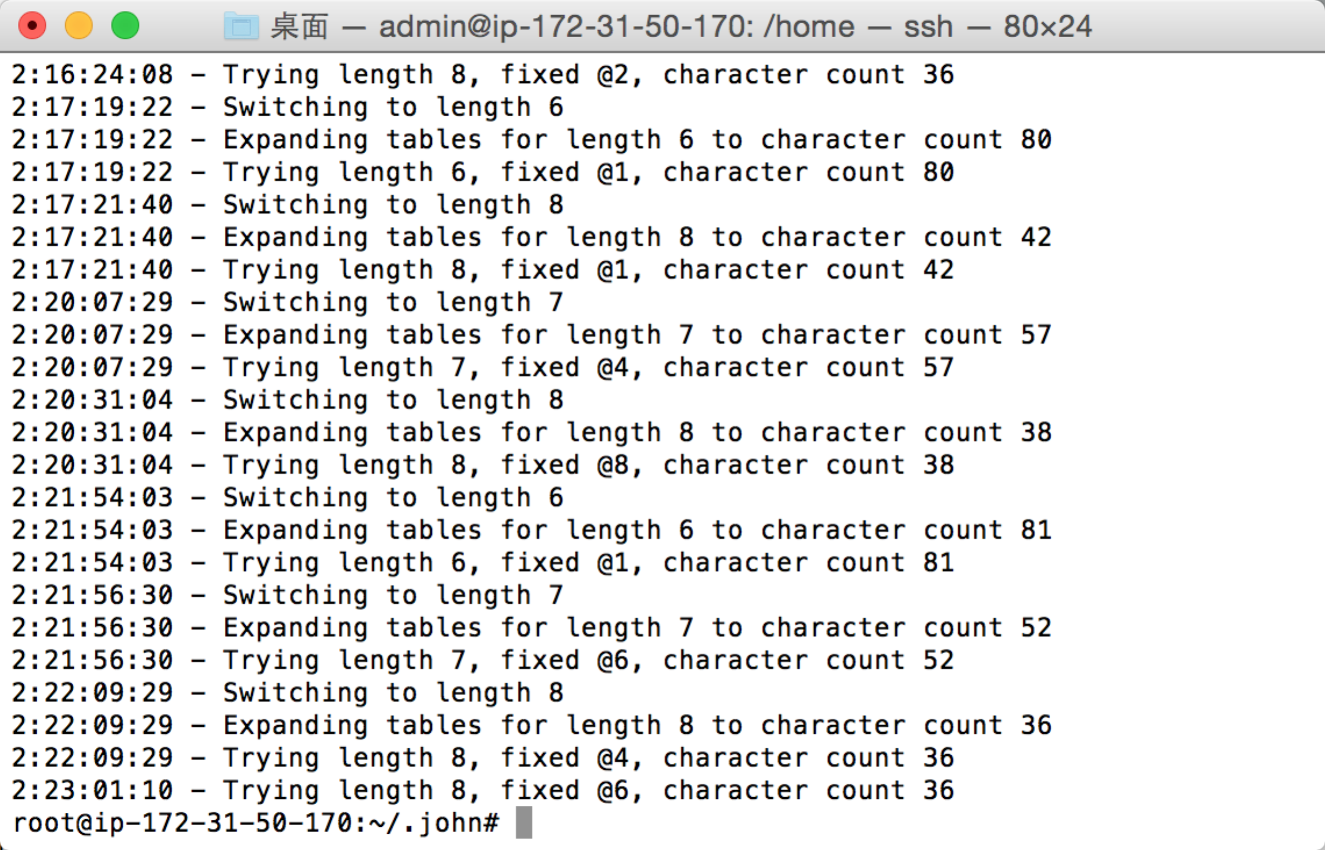

I also put my hashes on an online hash cracked sites. Here is the result.

The password “yyx199107191” and “computernetworkdefense” are not cracked successfully, because it is too long. So the longer our password is, the harder to decrypt it.

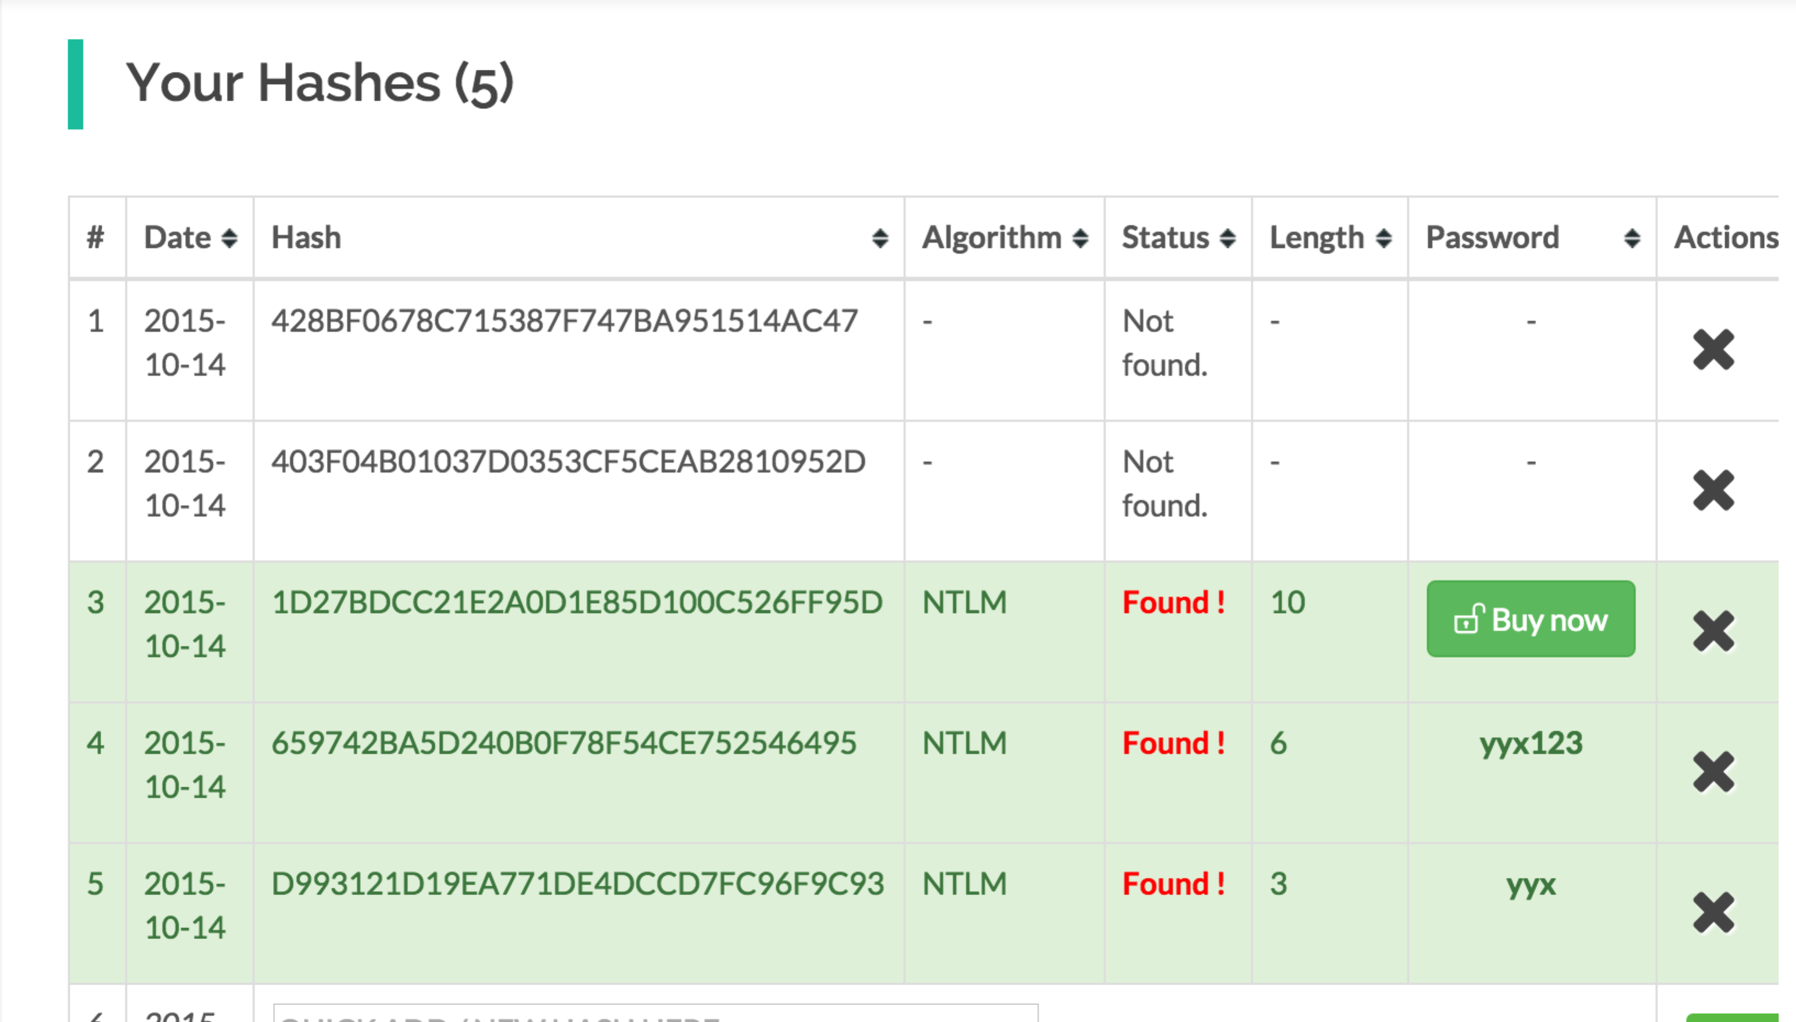

So the last two NTLM hashes can not be cracked in a limit time. If you have any way to crack them, please tell me, thanks.

2.

I first tried the given example. I created the oval key and add a name called “example” valued “Hello World”. Here is the result.

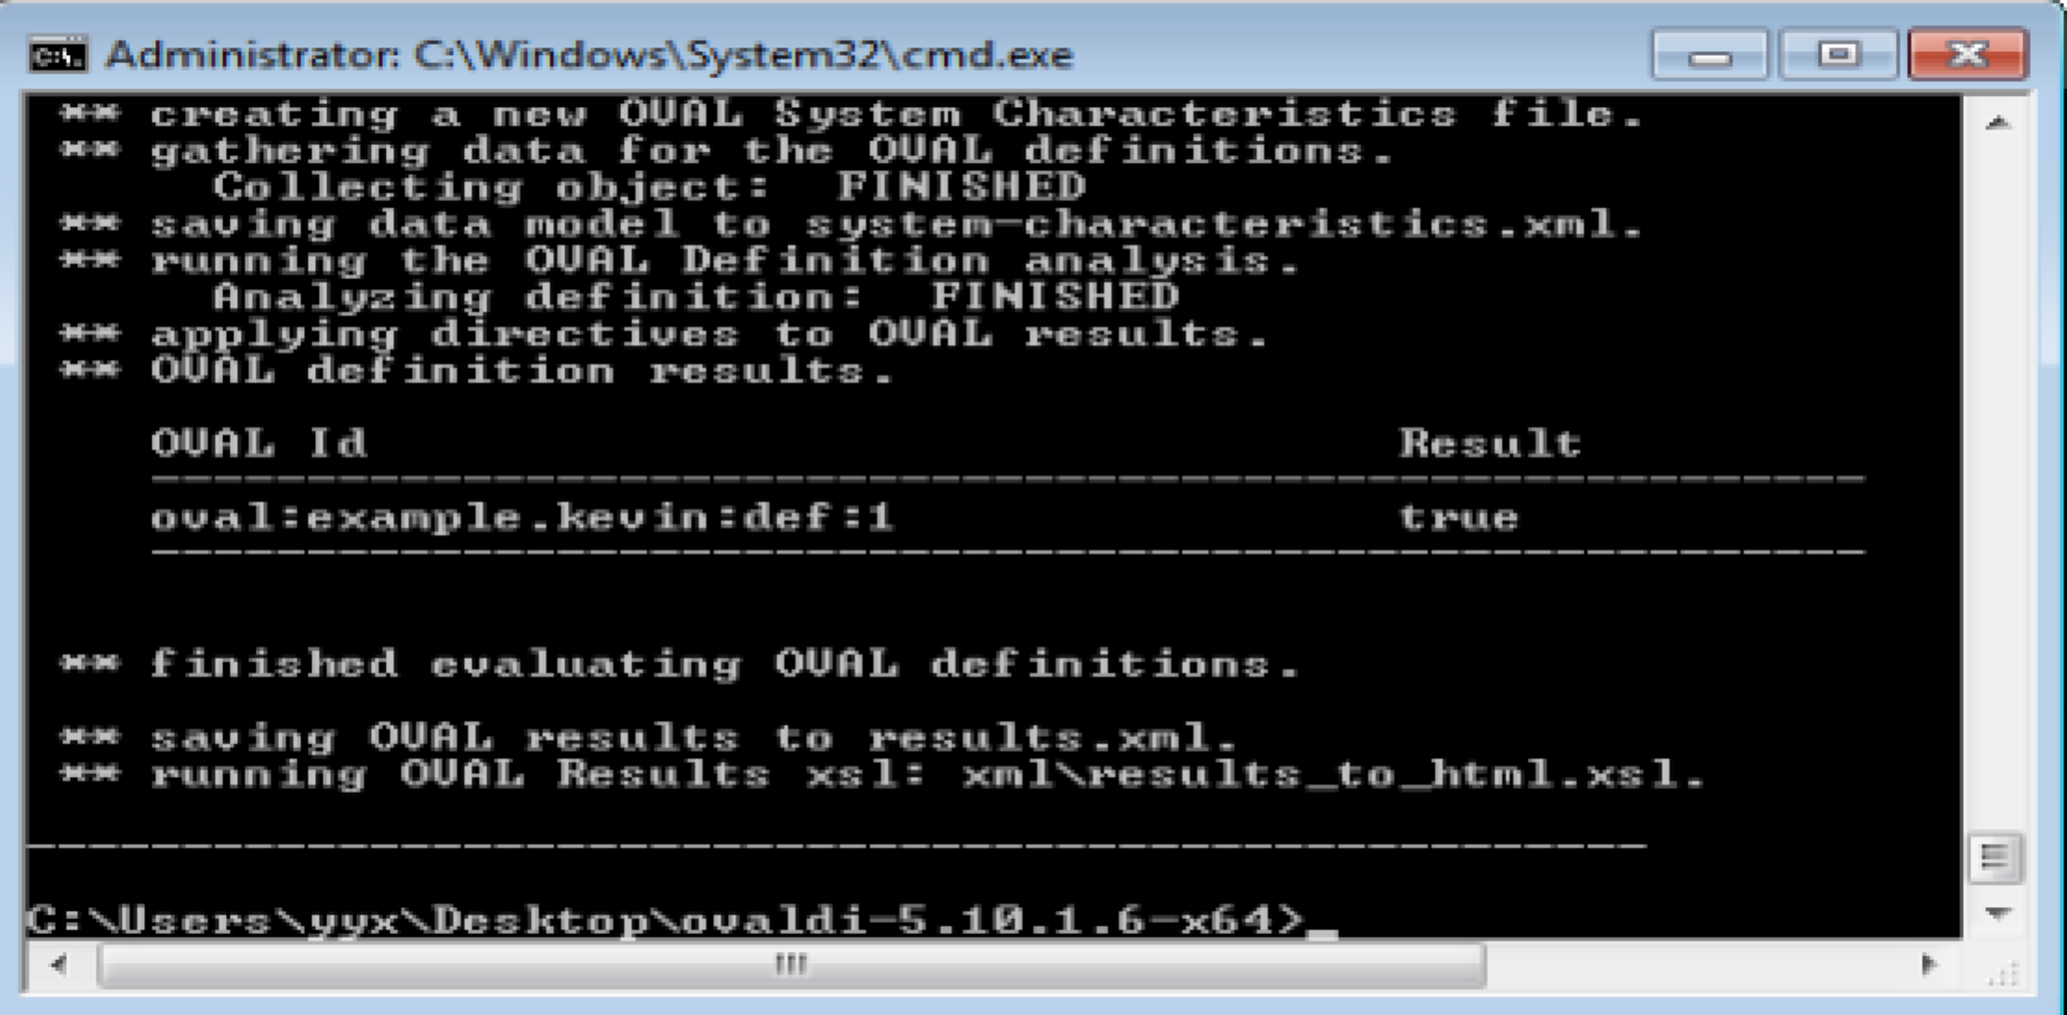

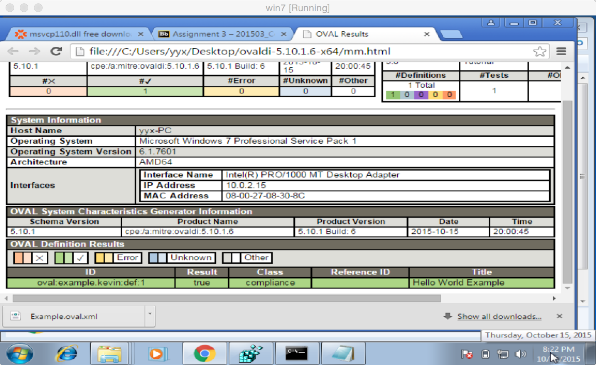

Then I find information through the internet to finish the 3 tasks.

First I need to check that windows is not storing LM hashes of user password.

For this one I need to focus on the following options.

The NoLmHash key in registry editor

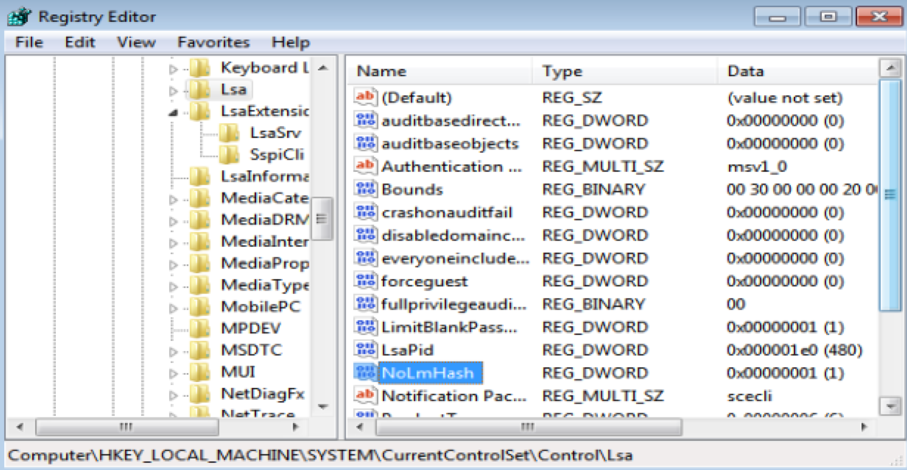

and the network security: Do not store Lan Manager Hash Value……

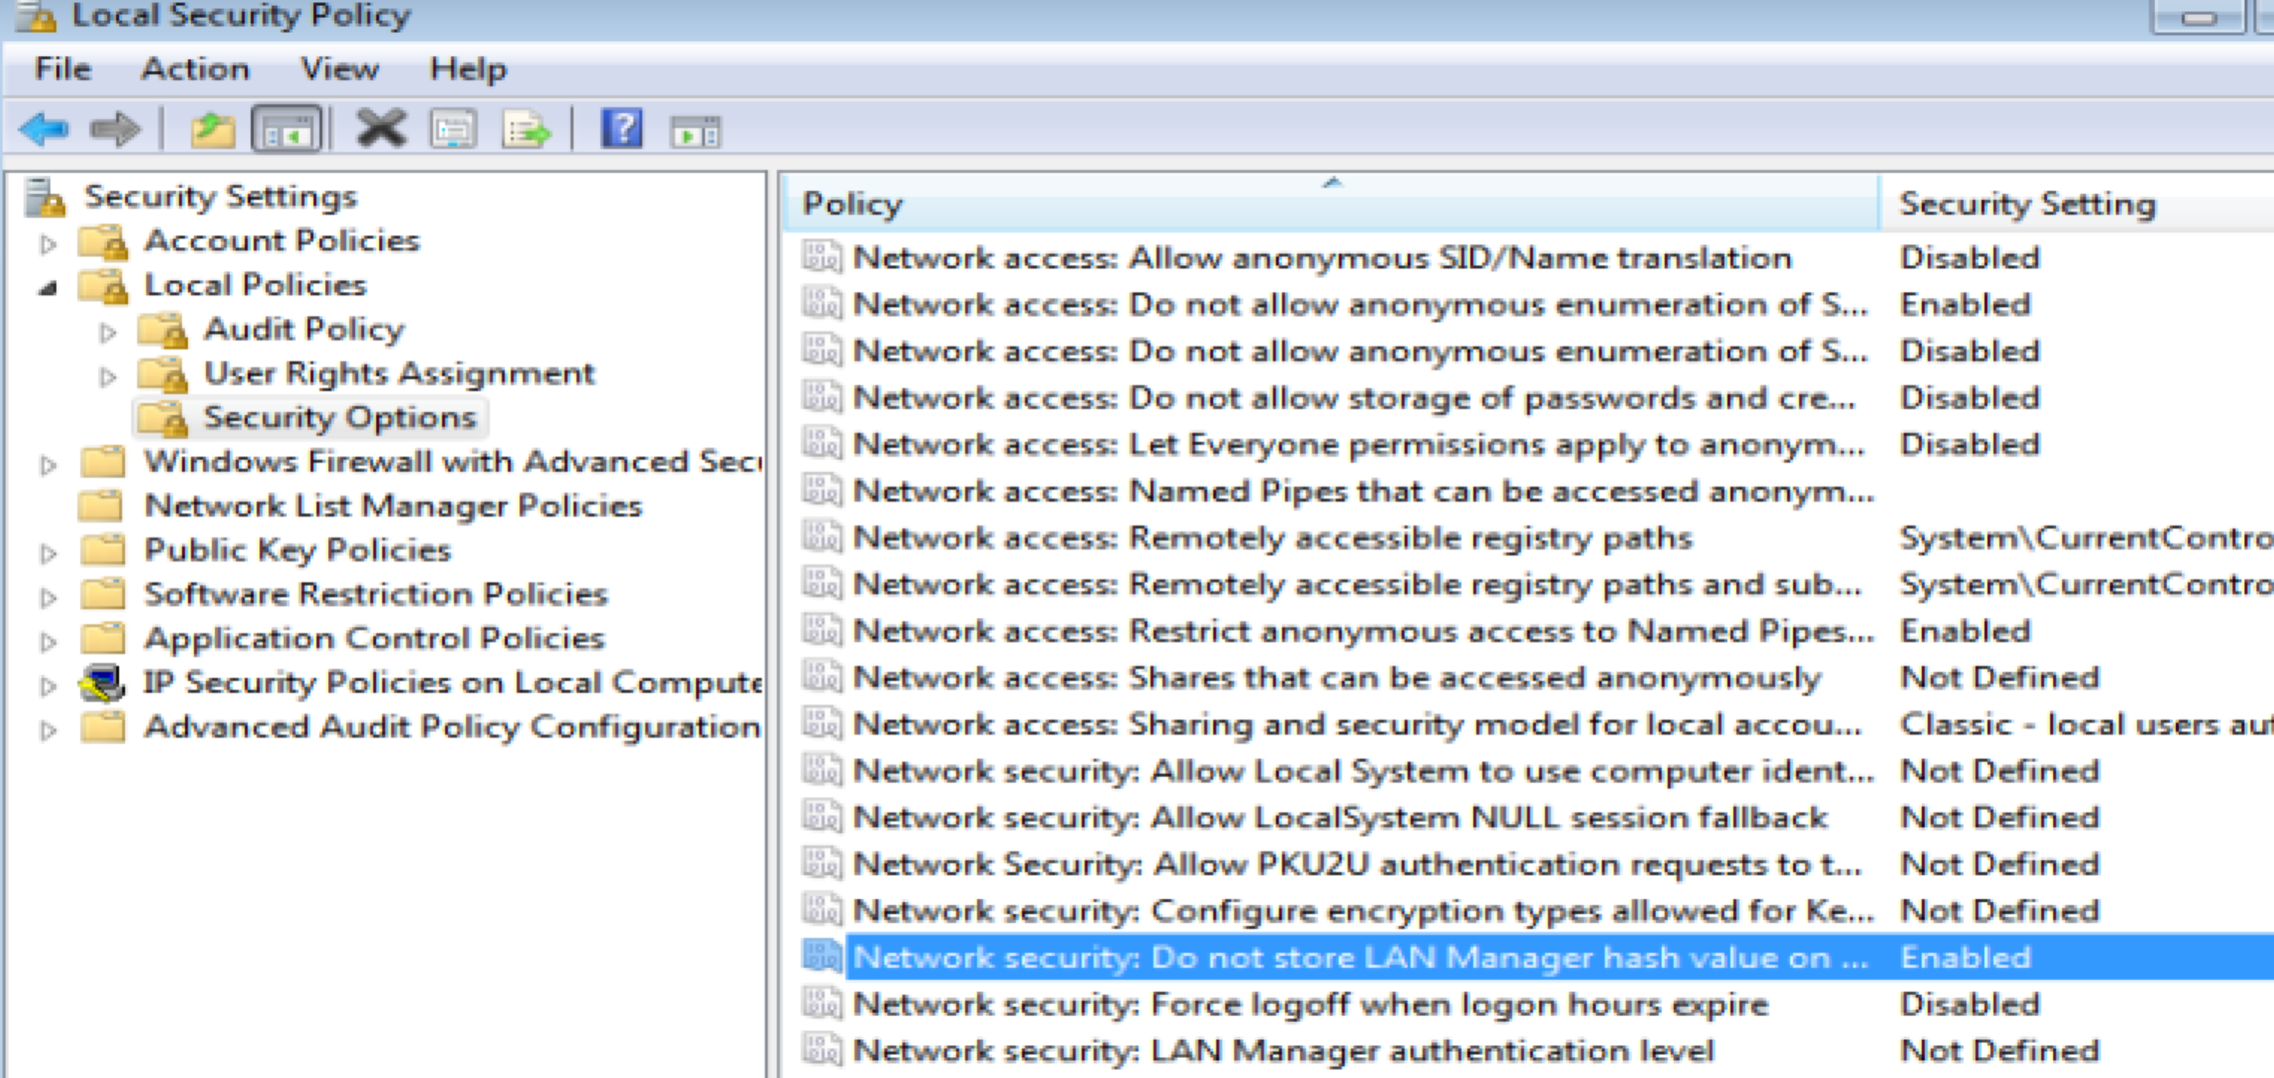

these two are equal. Maybe the local security policy window is just the GUI of the registry keys. So I just need to use oval to check the path of NoLmHash

so for registry_object

<hive>HKEY_LOCAL_MACHINE</hive>

<key>SYSTEM\CurrentControlSet\Control\Lsa</key>

<name>NoLmHash</name>

for registry_state

<value>1</valud>

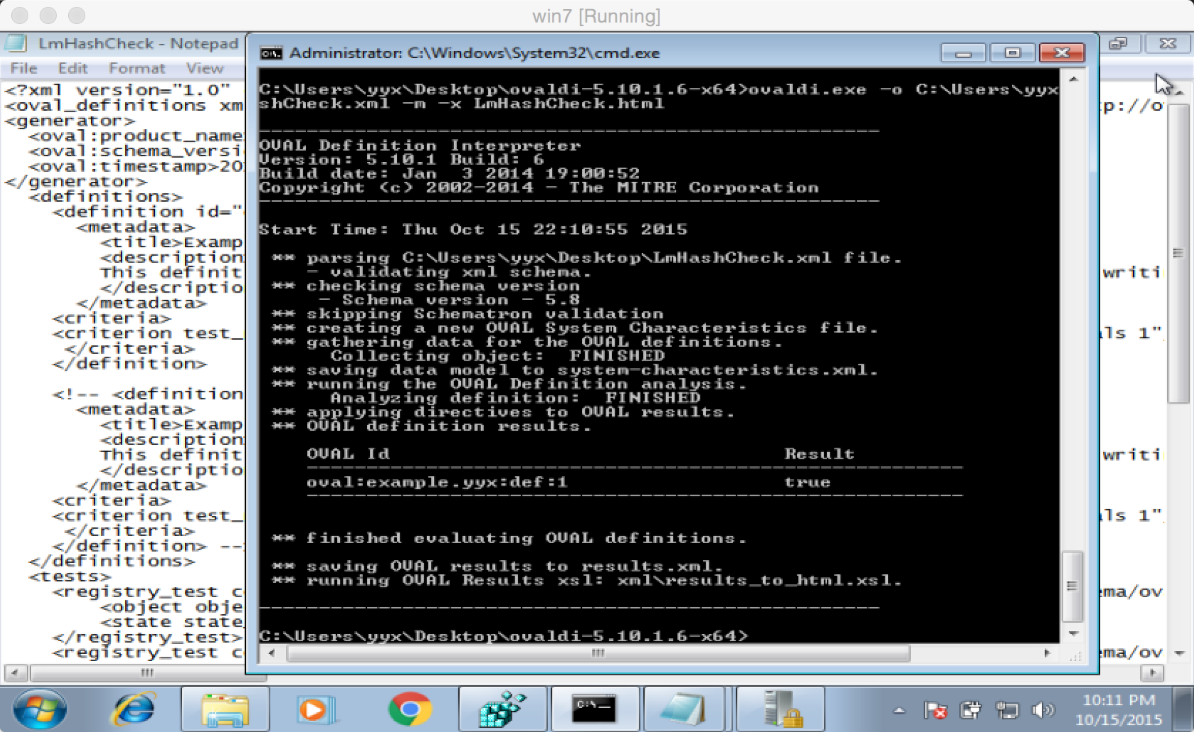

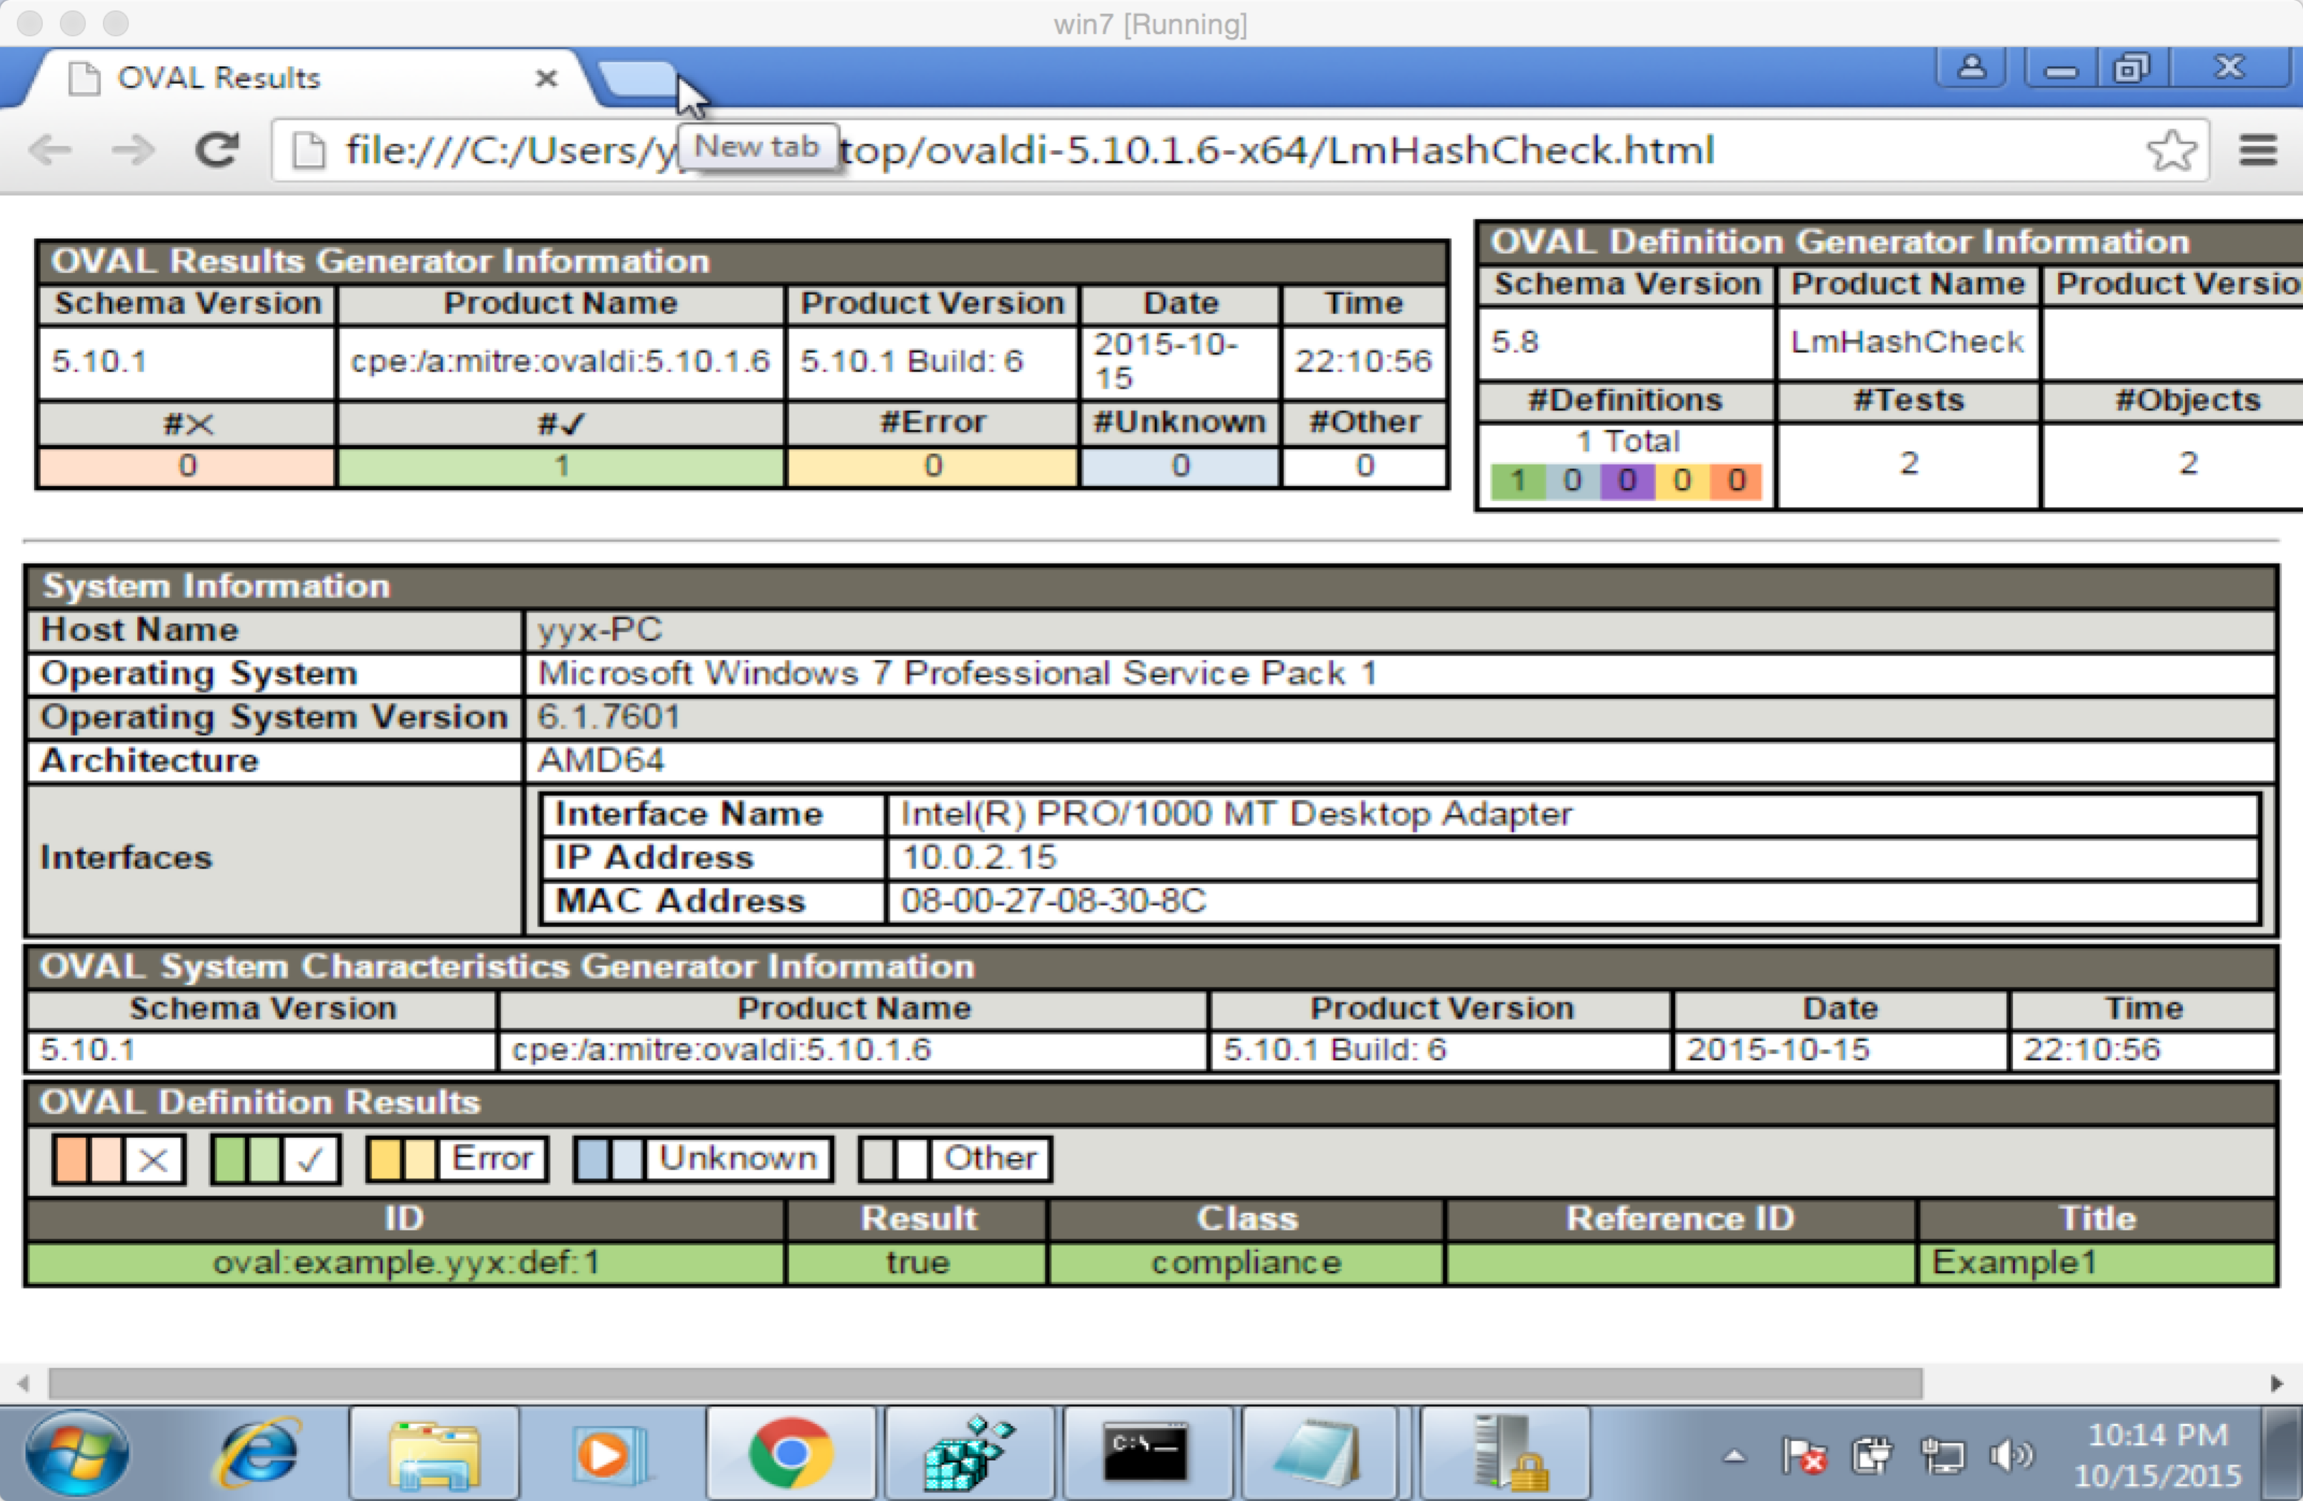

we can see the result is true.

For the second one, it is a little bit complex. I first try two find the keys in registry editor but I just can't find it. So I change my mind. I use file object and use its path to find the file and check its version

Here is the version of regedit.exe

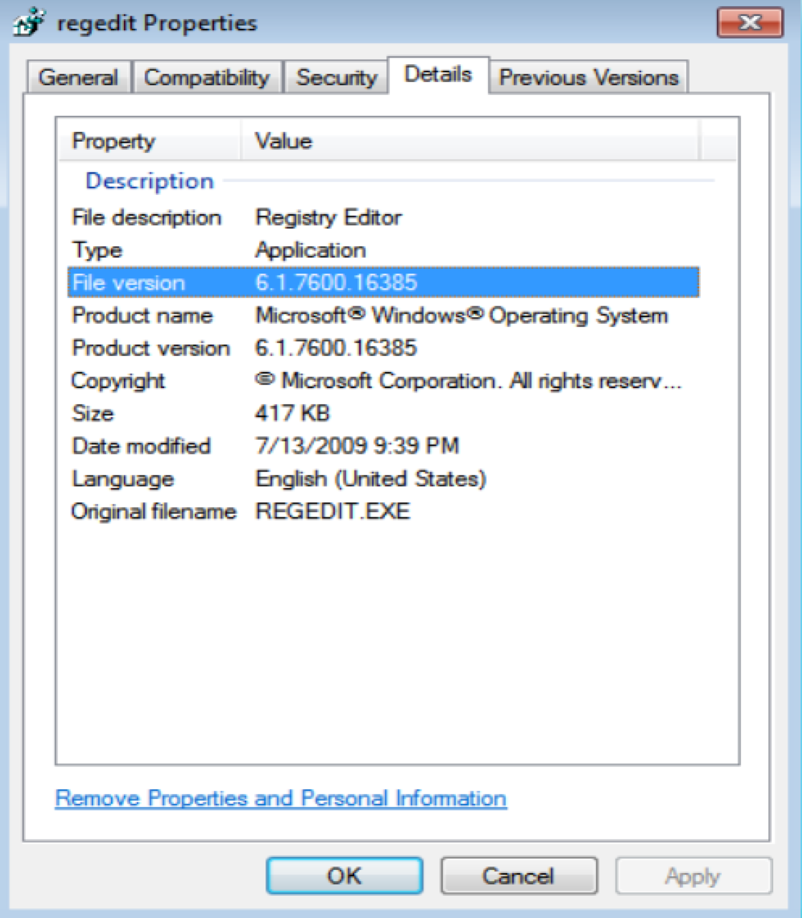

what is hard is to understand oval grammar and how to use it.

In this question we need to use file object and its path in file system.

<file operation=’equals’>C:\Windows</path>

After I know this, all become easy.

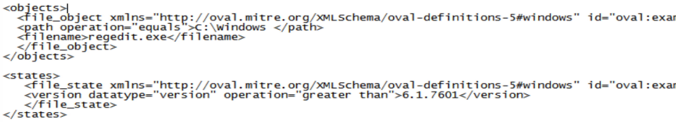

I also test if change the version to 6.1.7600 it return true, if I change the version to 6.1.7601 it return false. So it shows that my operation is right.

For the third one, the service could be open by services.msc

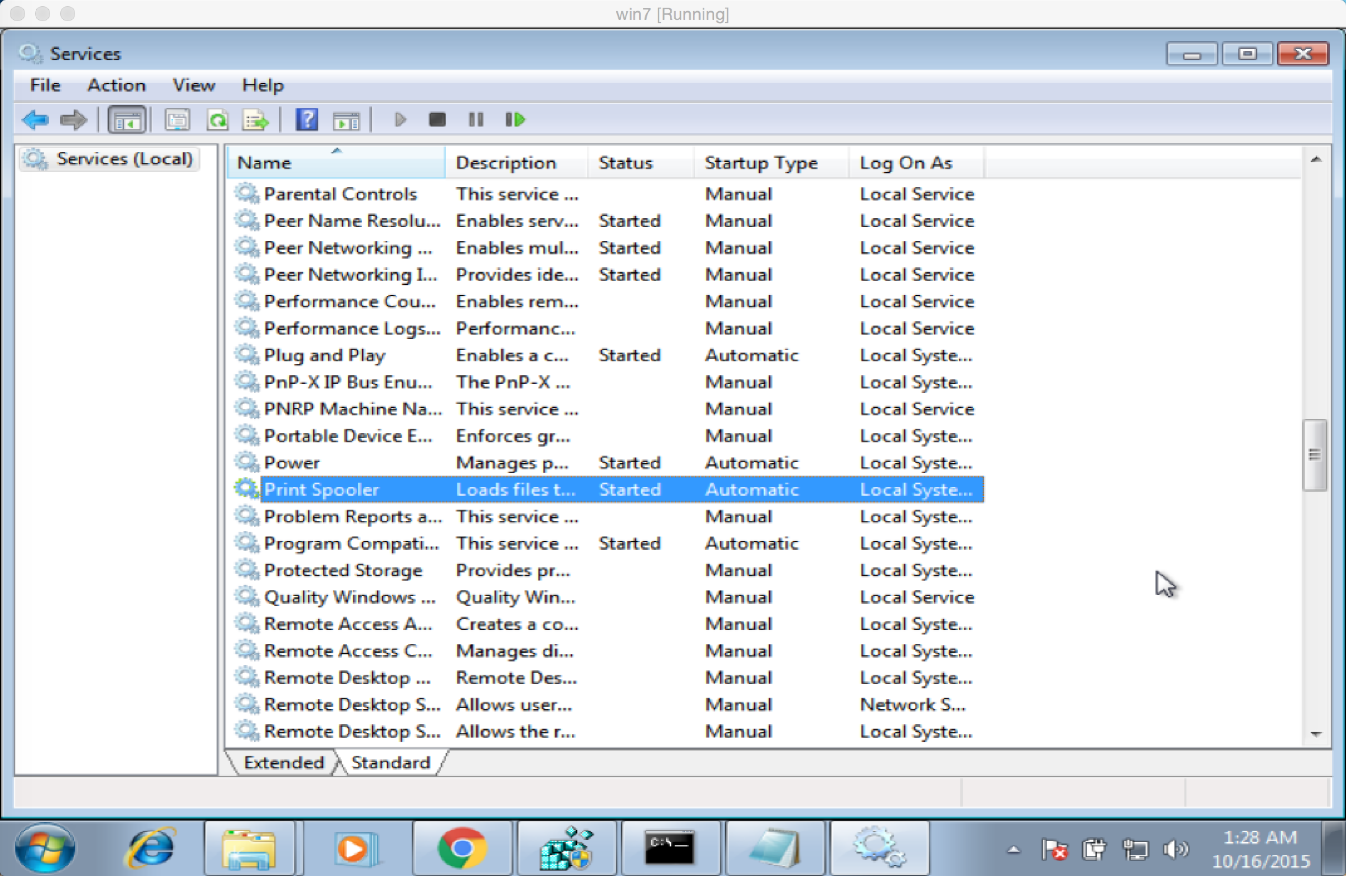

The print spooler is in the following position of the registry editor.

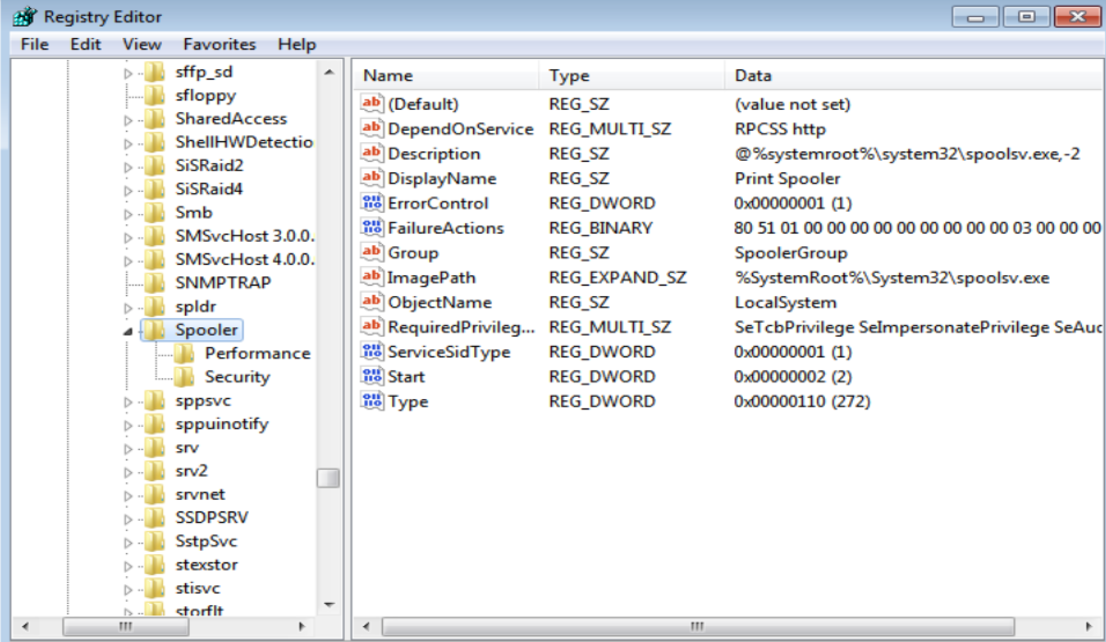

The value named start is responsible for the state of spooler. 2 is automatic, 3 is manual, 4 is disabled.

Main part of this question is

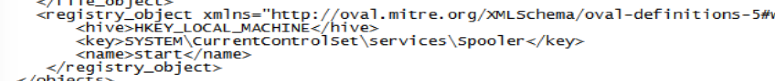



So the result of the three questions are all true, here is the screen shot. I will attach the .xml file and the html file in my submission.

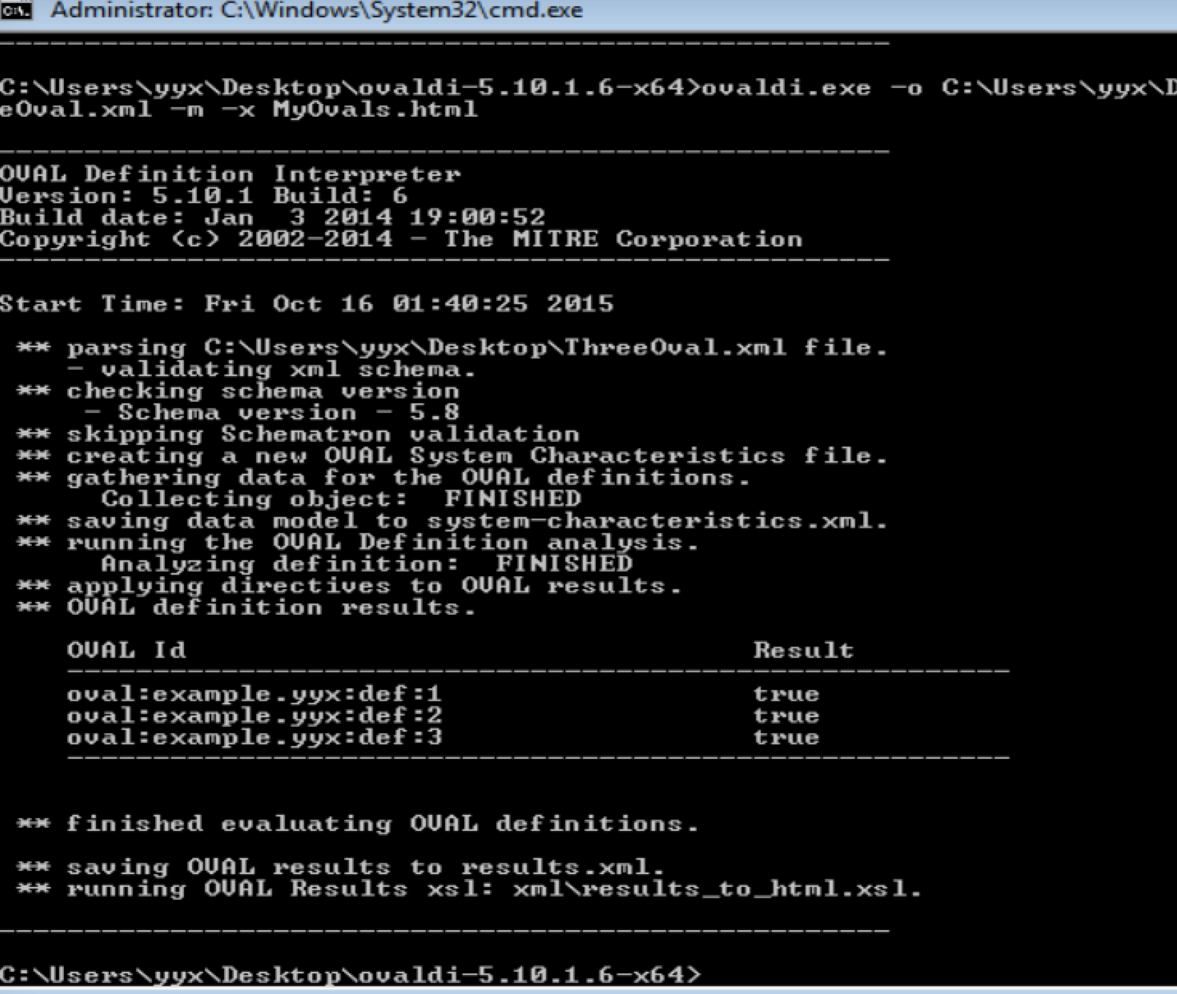

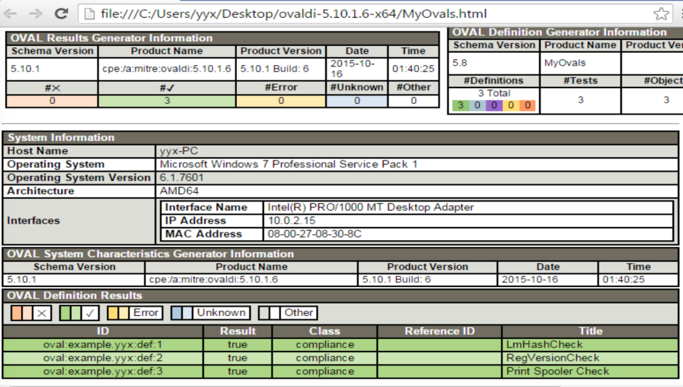

Summary:

From this question, I learnt the basic knowledge of OVAL. In my opinion, we can use it check the state of our computer (include service, software version and so on). If we write a lot of oval definitions we want. We could protect our computer in some degree. It is because we check the services that may be hacked by others. So it is somehow useful. Anyway, it is a better way to check the status of our computers if we have spent hundreds of hours to write a perfect oval file.

3.

I will attach the screenshot in my submission because it is not clear in this .doc file.

(1)

for the first query, we need to write 3 splunk query for sIP, dIP and for sIP-dIP

pair

<1>

search:

source="netflow_example_for_class.csv" host="YixindeMacBook-Pro.local" sourcetype="csv" | stats sum(bytes) as totalBytes count(packets) AS totalPackets by sIP | sort -totalBytes -totalPackets

I sort them by totalBytes and totalPackets desc, so it looks better.

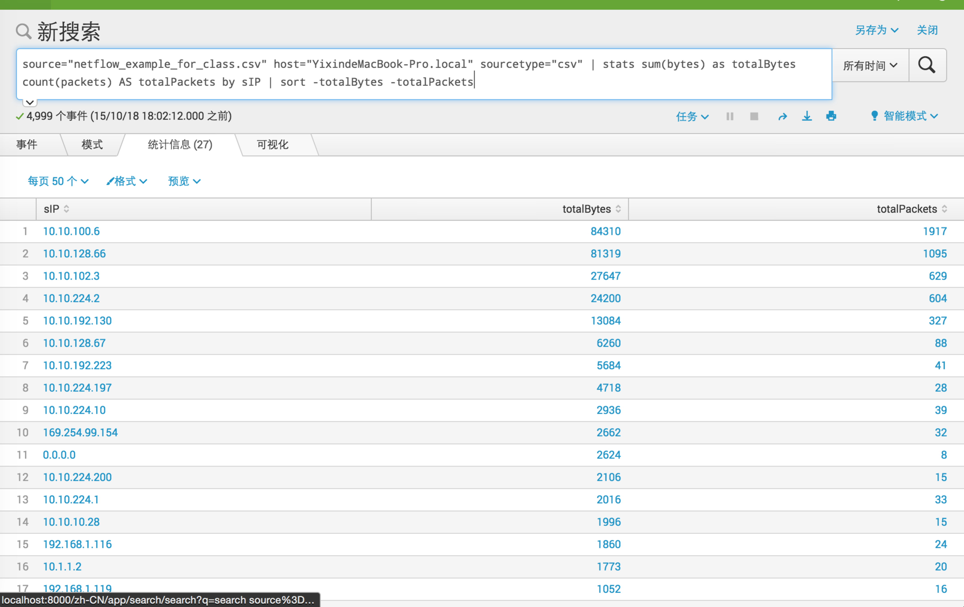

<2>

search:  
source="netflow_example_for_class.csv" host="YixindeMacBook-Pro.local" sourcetype="csv" | stats sum(bytes) as totalBytes count(packets) AS totalPackets by dIP | sort -totalBytes –totalPackets

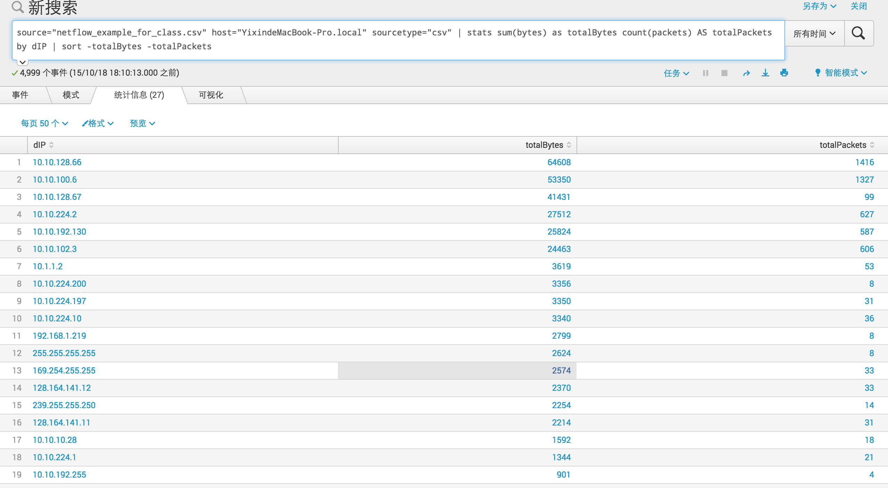

<3>

search:

command:

source="netflow_example_for_class.csv" host="YixindeMacBook-Pro.local" sourcetype="csv" | stats sum(bytes) as totalBytes count(packets) AS totalPackets by sIP dIP | sort -totalBytes –totalPackets

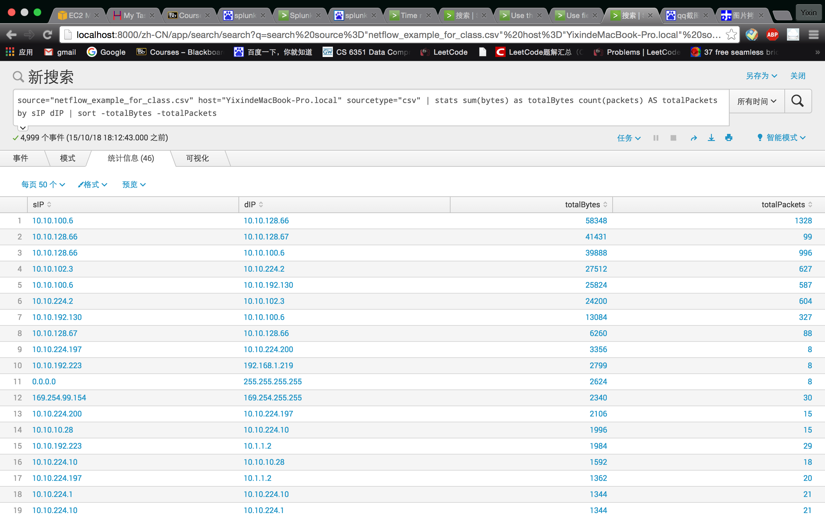

(2)

I need to write two searching command:

<1>

the most common third octlet for source address is 100 (1919 times)

search:

source="netflow_example_for_class.csv" host="YixindeMacBook-Pro.local" sourcetype="csv" | rex field=sIP "\d{1,3}\.\d{1,3}\.(?<oct_ip>.*)\.\d{1,3}" | stats count(oct_ip) as OCT_IP_NUM by oct_ip | sort -OCT_IP_NUM

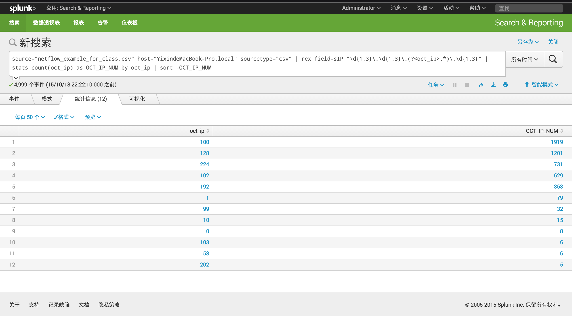

<2>

the most common third octlet for destination address is 128(1524 times)

source="netflow_example_for_class.csv" host="YixindeMacBook-Pro.local" sourcetype="csv" | rex field=dIP "\d{1,3}\.\d{1,3}\.(?<oct_ip>.*)\.\d{1,3}" | stats count(oct_ip) as OCT_IP_NUM by oct_ip | sort -OCT_IP_NUM

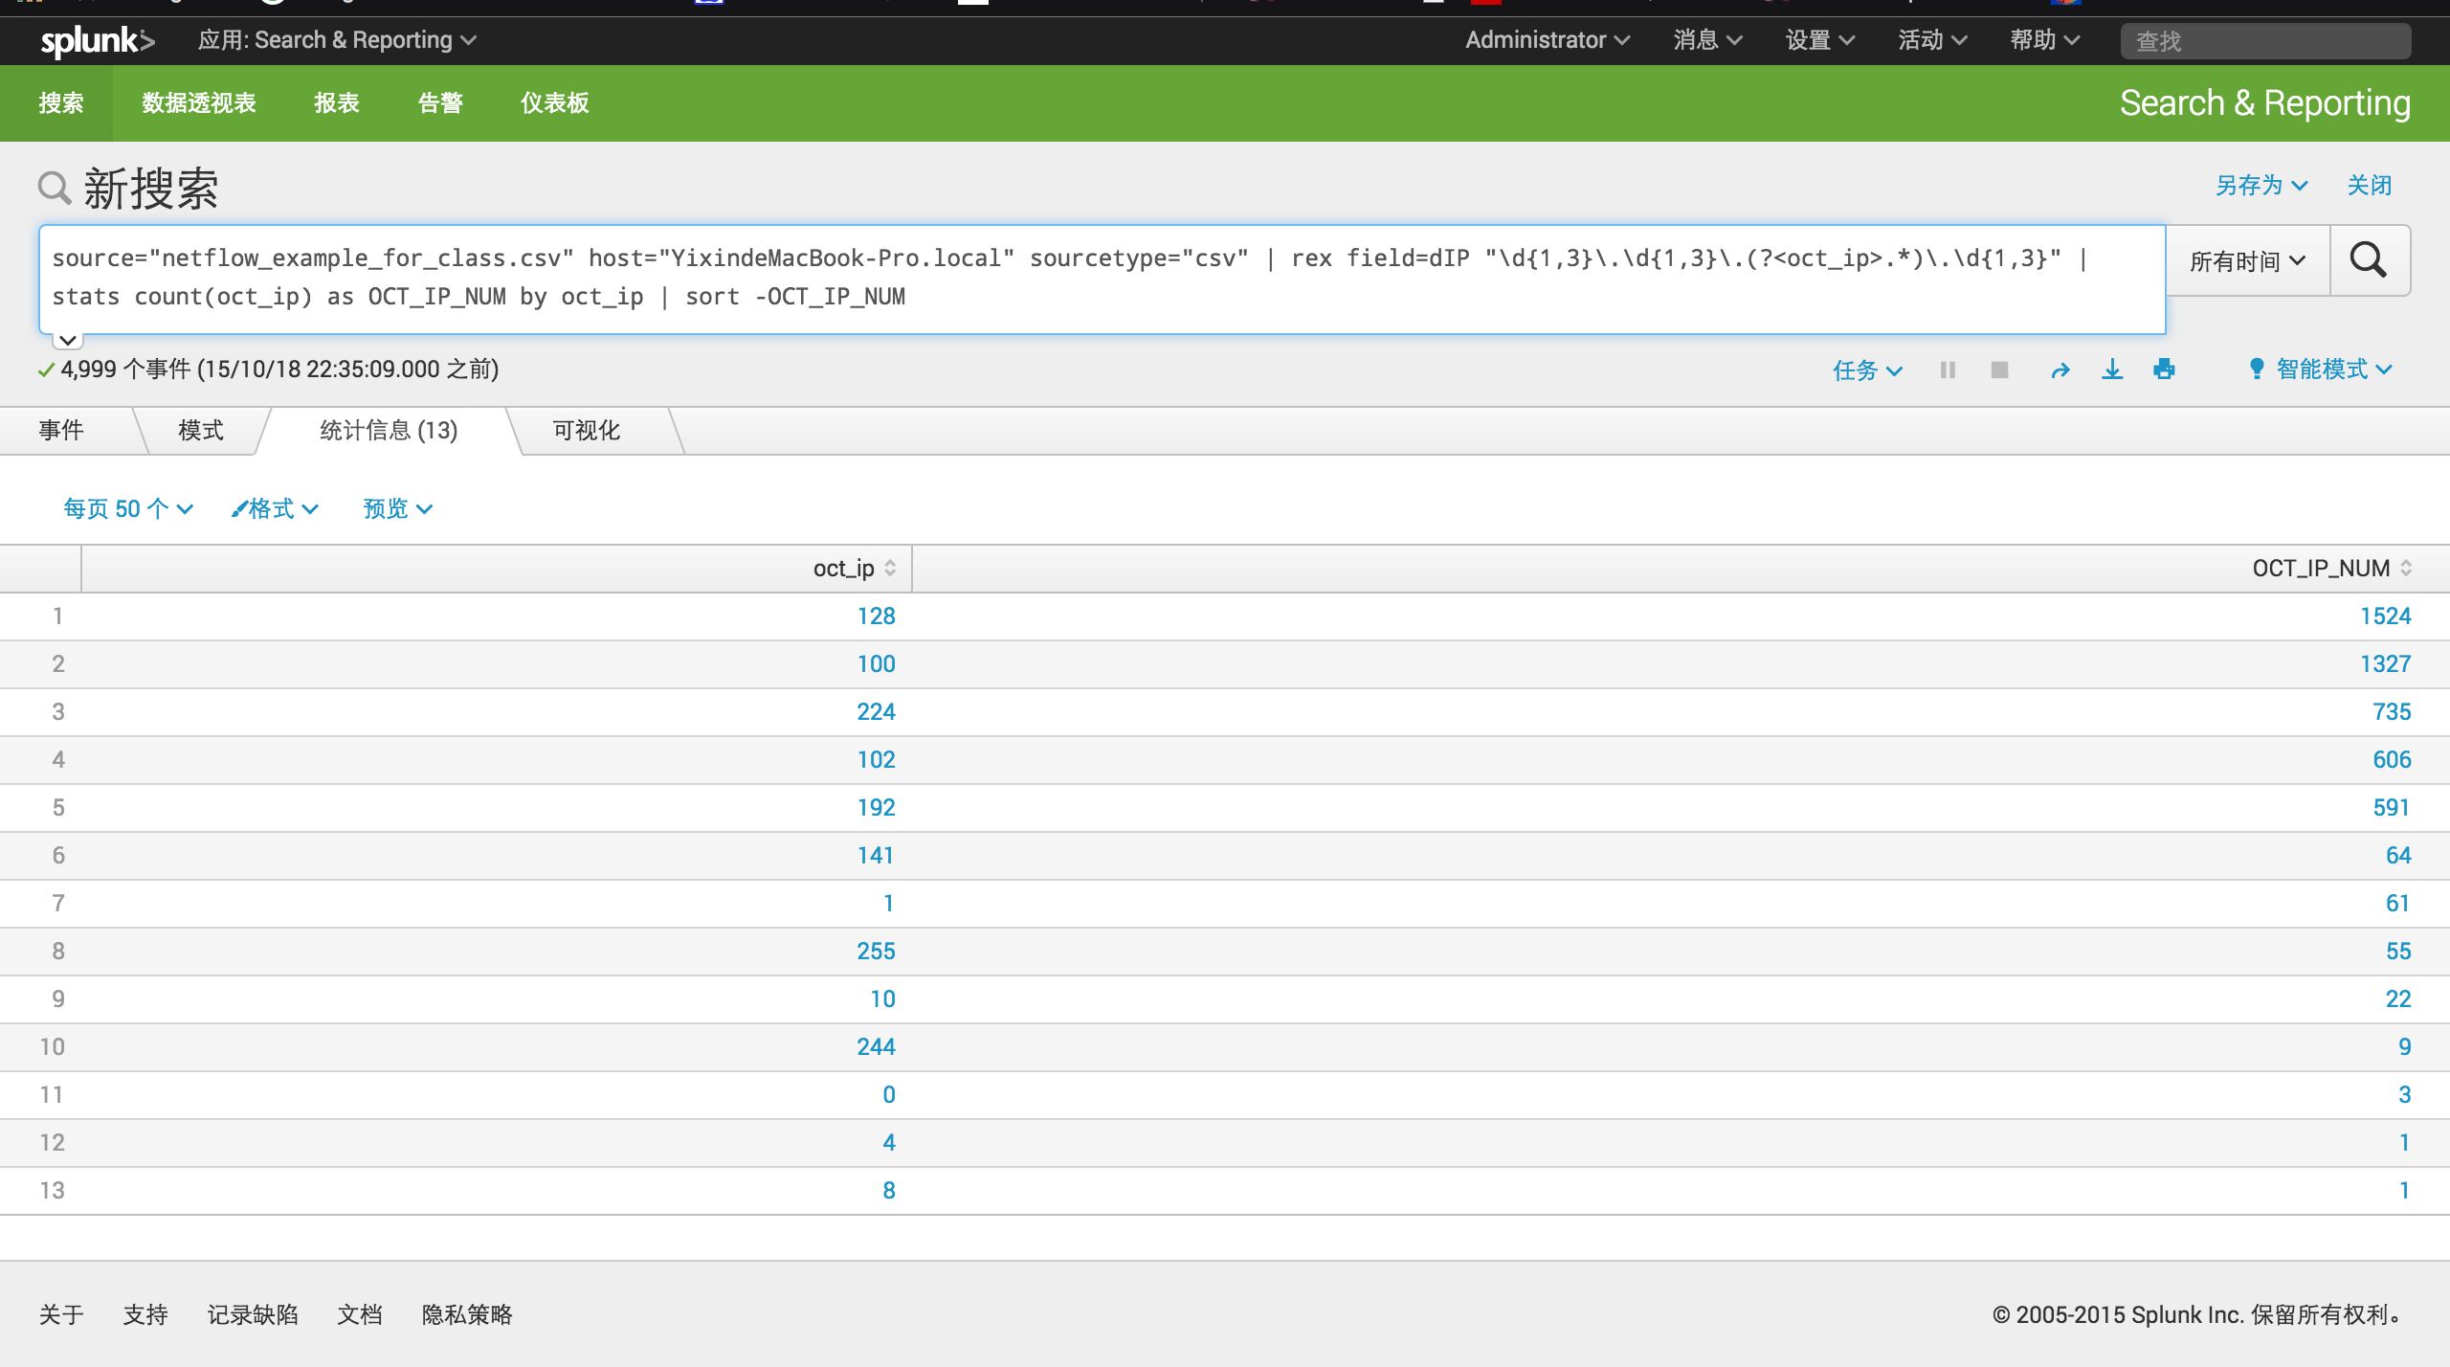

(3)

I need write two searching commands like question (2)

<1>

the most common last octlet for source address is 6

commands:

source="netflow_example_for_class.csv" host="YixindeMacBook-Pro.local" sourcetype="csv" | rex field=sIP "\d{1,3}\.\d{1,3}\.\d{1,3}\.(?<oct_ip>.*)" | stats count(oct_ip) as OCT_IP_NUM by oct_ip | sort -OCT_IP_NUM

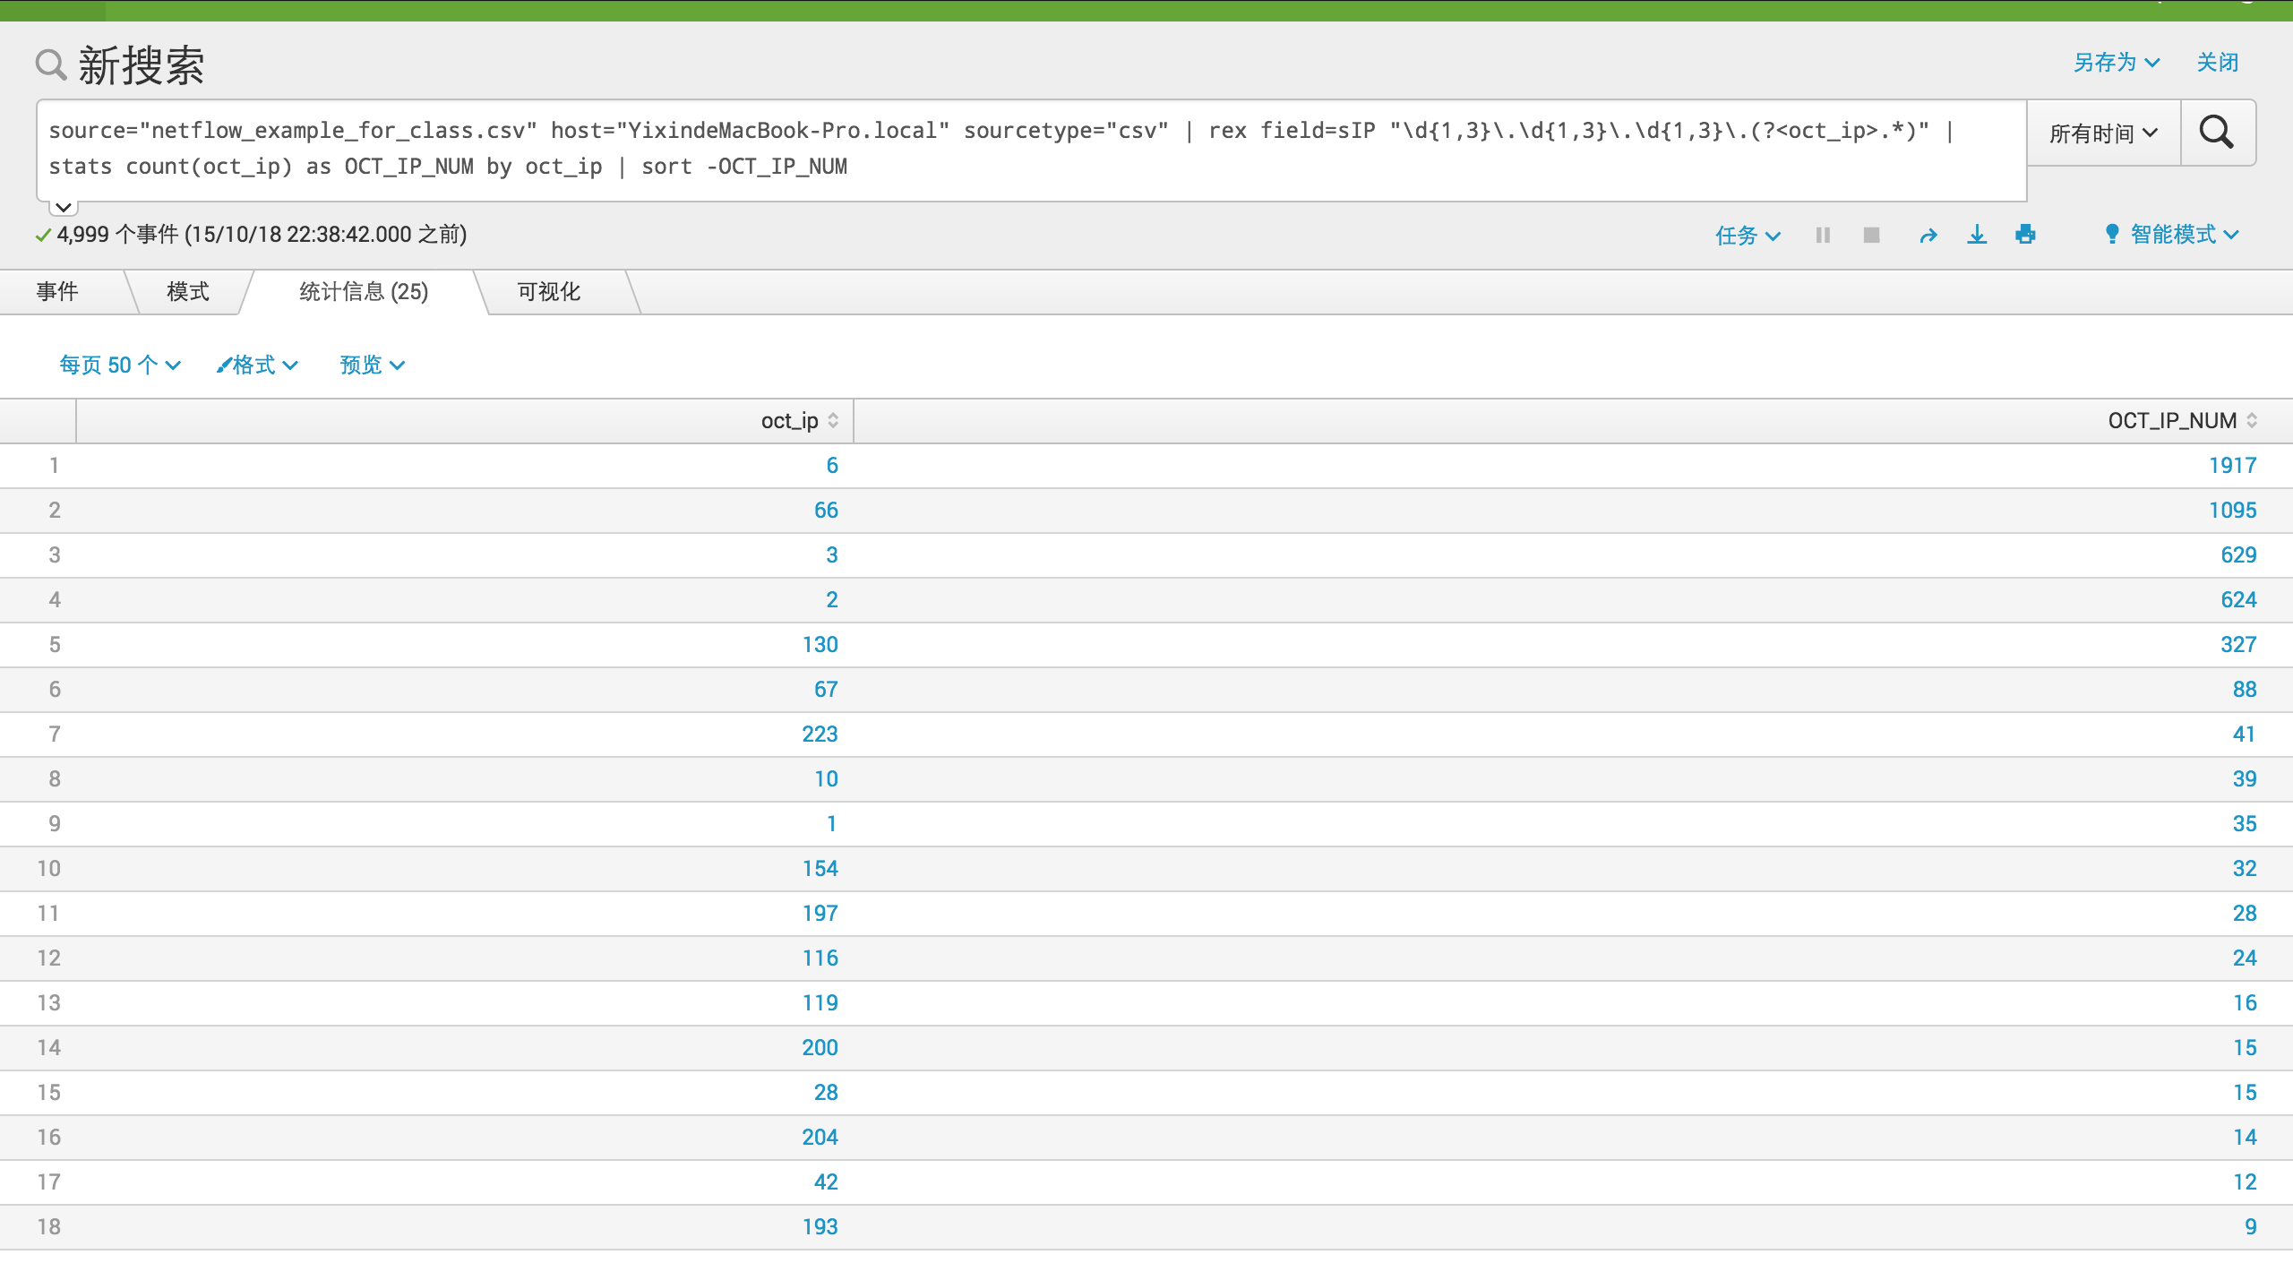

<2>

the most common last octlet for destination address is 66

source="netflow_example_for_class.csv" host="YixindeMacBook-Pro.local" sourcetype="csv" | rex field=dIP "\d{1,3}\.\d{1,3}\.\d{1,3}\.(?<oct_ip>.*)" | stats count(oct_ip) as OCT_IP_NUM by oct_ip | sort -OCT_IP_NUM

